………………………...................ORTAOKULU
5.
SINIF
PUAN:
. 2025-2026 EĞİTİM ÖĞRETİM YILI Adı ………………………………………………
sb
İNGİLİZCE Soyadı …………………………………………
1. DÖNEM 1. YAZILI Sınıfı …………………. No …………………. ………………
1. Soru  (15 Puan) | 2. Soru  (15 Puan) | 3. Soru  (15 Puan) | 4. Soru  (15 Puan) | 5. Soru  (25 Puan) | 6. Soru  (15 Puan) | Aldığı  Puan
………… | ………… | ………… | ………… | ………… | ........... | …….
Aşağıda verilen açık uçlu soruları cevaplayınız.
Sorubak

S1
Read the text and complete the sentences with the correct words.
Clubs and Special Days at River School
Hello, I’m Lisa. At River School we have many clubs. The Science Club meets on Tuesday in Lab 2. The Music Club meets on Thursday in the music room. Our principal is Ms Carter. On our National Day, we decorate the hall with flags and sing the anthem together. We must arrive on time and keep the rooms clean.
- Our ------------ is Ms Carter.
- The Science Club meets on ------------ in Lab 2.
- The Music Club meets in the ------------
- On our National Day, we decorate the hall with ------------
- We must ------------ on time.
S2
Read the dialogue and answer the questions.
Hana: Hi, Ben. Why are there red and white flags in the hall?
Ben: We’re getting ready for 23 April National Sovereignty and Children’s Day in Türkiye.
Hana: What will you do?
Ben: We’ll sing songs and read poems on the stage.
a) What is the name of the national day?
✎ …

b) What do the students do on that day?
✎ …

S3
Read the texts carefully and complete the table.
Text A
Hello! My name is Omar. I’m 12 years old. I’m from Egypt. I study at Gazi Secondary School. My favourite school club is the Drama Club.
Text B
Hi! I’m Mia. I’m 13 years old. I’m from Canada. I go to Sun Valley Middle School. My favourite club is the Chess Club.
Complete the table.
Name | Age | Country | Favourite Club
______ | ______ | ______ | ______
______ | ______ | ______ | ______

S4
Look at the pictures and write the names of the school clubs under the pictures.
 |  |  | 
.............................. | .............................. | .............................. | ..............................

S5
Read the sentences below and write which club they are in. Use the Word Bank.
Word Bank: Science Club • Art Club • Music Club • Drama Club • Chess Club • Sports Club
Sentences
- Maya: I love acting on the stage and learning lines.
- Leo: I like painting posters and sketching.
- Sara: I enjoy playing the violin and singing in the choir.
- Yusuf: I’m good at planning moves and solving puzzles.
Write your answers
■ Maya is in the _______________.
■ Leo is in the _______________.
■ Sara is in the _______________.
■ Yusuf is in the _______________.

S6
Write the name of the country under each flag.
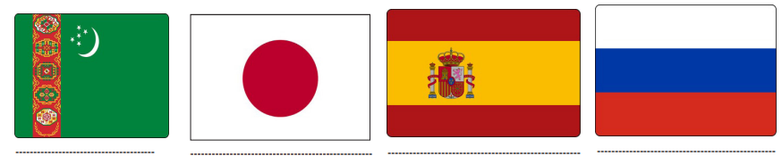

Not:Sınav süresi 40 dakikadır. …………………………….

