____________________ HIGH SCHOOL 2026 -2027 EDUCATIONAL YEAR 1ST TERM 1ST WRITTEN EXAM FOR 10Th GRADES
(Senaryo 1)
Name - Surname: Class - Number:

A. Match the words / phrases to the definitions below. (5x2=10P)
I’m Duru. My country is Turkey. The capital city of Turkey is Ankara. The language is Turkish. Our national day is October 29. Turkish culture is very rich and beautiful.

National day: a special day when people celebrate an important event in their country
Country: an area of land that has its own government
Language: a type of communication used by the people of a particular country
Culture: the habits, traditions, and beliefs of a country
Capital: the most important city in a country

B. Read the text and write the names of the people who do the activities. (5x2=10P)
I’m Jack. I live with my family in a big house in a quiet neighbourhood. Our house has three bedrooms, a living room, a kitchen and two bathrooms. My favourite room is my bedroom because it is comfortable and bright. My mother, Jane, usually cooks meals in the kitchen, and my father, Tim, waters the plants in the garden. In the evenings, we all sit on the sofa in the living room and watch TV together. At weekends, my sister, Olivia, rides her bike in the park near our house. I love our neighbourhood because it is peaceful and there are many shops and green spaces around us.

Find someone who
cooks meals at home Jane
rides a bike in the park Olivia
waters the plants Tim
likes his bedroom Jack
watches tv in the evenings Jane, Jack, Olivia, Tim

C. Read the text and answer the question. (6x2=12P)
I’m Mia, and I’m a student at a boarding school in England. We live at school during the week, so we learn to be independent and responsible. Our daily schedule is busy. We attend lessons in the morning and do our homework in the afternoon. After classes, students can join extracurricular activities such as drama, music, and sports clubs.
At first, I felt anxious because I was away from my family and had to manage my time carefully. However, my teachers and classmates supported me, and I became more confident. Our school also celebrates important national days. Last month, we organised an event with music, speeches, and traditional food to learn about different cultures.

1. Where is Mia?
She is at a boarding school in England.
2. What does Mia do in the afternoon?
She does her homework in the afternoon.
3. What are the extracurricular activities at school?
Drama, music, and sports clubs.
4. Why did Mia feel anxious?
She was away from my family.
5. Who helped Mia become more confident?
Her teachers and classmates.
6. Why did they organize an event last month?
To learn about different cultures.

D. Write the types of schools and the activities students do at each school. (12x2=24P)
I’m Sam. I want to study at a Fine Arts School because I like to draw and paint. My friend wants to study at a Vocational School because he likes to fix cars and design new things. . STEM School students build robots and test ideas. Forest School students explore nature and learn outside.

Forest School STEM School
explore nature build robots
learn outside test ideas

Vocational School Fine Arts School
fix cars play music
design new things draw and paint

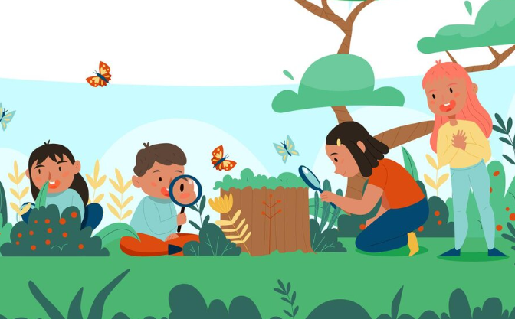

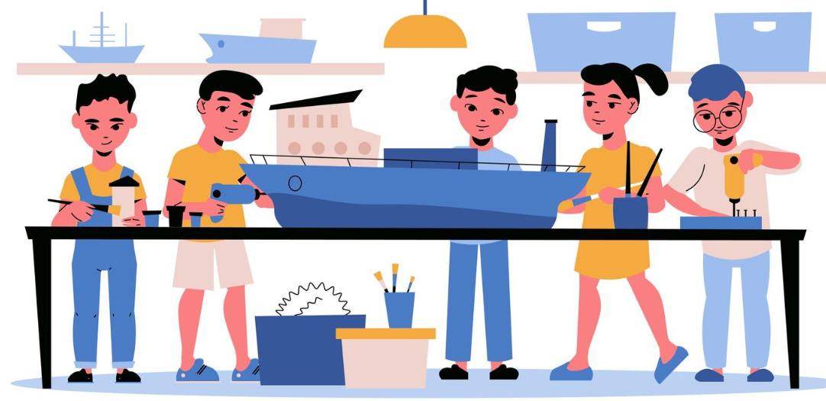
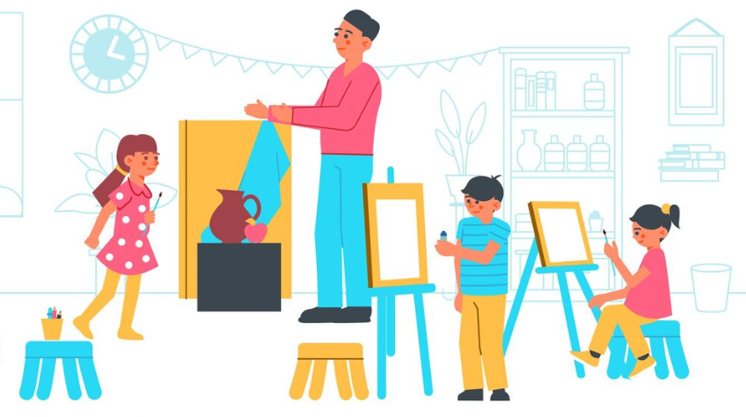

E. Complete the sentences with the correct form of the words. Be careful about topics. (11x2=22P)
I usually have (have) breakfast at 7 o’clock and walk (walk) to school with my friends. But today, I am late, so I am walking (walk) to school alone. At school, we usually play (play) football in the sports field during breaks. However, it is raining (rain) today, so we are playing (play)chess in the classroom now.

Present Tense / Present Continuous Tense

1. School life is different everywhere, isn’t it?
2. She doesn’t take photos in the club, does she?
3. Jim and Rick are drinking coffee, aren’t they?
4. Efe can play the guitar, can’t he?
5. You can’t use your phone in the class, can you?
Question Tags

F. Write a paragraph about your school life. (20P)
* your school and school type * school anxiety or stress
* your daily lessons and extracurricular activities * national days and celebrations

__________________________________________________________________________________________________________________________________________________________________________________________________________________________________________________________________________________________________________________________________________________________________________________________________________________________
__________________________________________________________________________________
Students’ Own Answers

