____________________ SECONDARY SCHOOL 2026 -2027 EDUCATIONAL YEAR 1ST TERM 1ST WRITTEN EXAM FOR 10Th GRADES
(Senaryo 3)
Name - Surname: Class - Number:
A. There is one vocabulary mistake in each sentence. Find and correct it. (6x2=12P)
nationality → capital
country → language
celebration → attraction
attraction → celebration
good → famous
cultures → cuisines

1. Ankara is the nationality of Türkiye.
2. People in Brazil mainly speak Portuguese as their country.
3. The Eiffel Tower is a famous tourist celebration.
4. Republic Day is an important national attraction in Türkiye.
5. Spain is good for its beaches and football stadiums.
6. People taste different cultures and watch folk dancers at the festival.

B. Imagine this is your house. Write a short paragraph about your house and the activities you do at home. (8x3=24P)
___________________________________________________________________________________________________________________________________________________________________________________________________________________________________________________________________________________________________________________________________________________________________________________________________________________________________________________________________
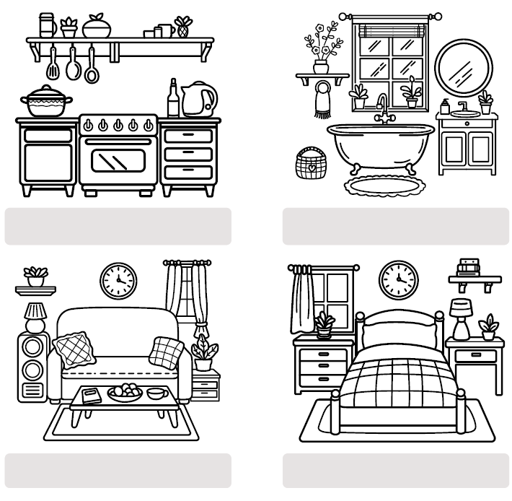
-watch TV -sleep
-read a book -do homework
-cook meals - brush teeth
-wash the dishes -take a shower

Students’ Own Answers

C. Read the text and complete the table. (5x4=20P)

School Life in Japan
Type of School  Public secondary school | Regular Activities  Studying different subjects, having lunch, cleaning classrooms | School Facilities  Library, gym, computer rooms, courtyard | School  Clubs  Basketball Club, Art Club, Music Club, Origami Club | Extracurricular  Activities  School festivals, sports competitions, cultural events

Many students in Japan attend public secondary schools. They study subjects such as Japanese, maths, science and English. Schools have libraries, gyms, computer rooms and courtyards. Students usually clean their classrooms and have lunch at school. After lessons, they can join clubs such as basketball, art, music and origami. They also take part in school festivals, sports competitions and cultural events. These activities help them develop new skills and make friends.

D. Read the text and answer the questions. (6x3=18P)
My name is Lukas, and I attend a Gymnasium in Germany. I study subjects such as German, maths, science and English. My school has a library, science labs, a gym and a courtyard. After lessons, I sometimes join the music club or play football with my friends. However, I often feel stressed before exams because I have a lot of homework and want to get good grades. My teachers encourage me to plan my time and take breaks. On 3 October, German Unity Day, our school is usually closed, but we learn about this important day in history lessons.

1. What kind of school does Lukas go to?
He goes to a Gymnasium.
2. What subjects does Lukas study there?
He studies German, maths, science and English.
3. What does Lukas join after school?
He sometimes joins the music club.

4. Why does Lukas feel stressed?
He has a lot of homework and wants to get good grades.
5. How does Lukas cope with stress?
His teachers encourage him to plan his time and take breaks.
6. Do people in Germany celebrate a national day?
Yes, they do. They celebrate German Unity Day on 3 October.

E. Fill in the blanks using given words / phrases. (13x2=26P)
*Present Tense / Present Continuous Tense
My name is Nisan. I am in the library now. I usually read (read) books here, but today I am studying (study) maths. This week is our exam week. Ece and Deniz usually have (have) lunch during the break. Then, they play volleyball or go to the music club to play the piano. However, today they are revising (revise) their notes. Ömer feels (feel) very anxious because of the exams. Our teacher sometimes helps (help) him relax. Now, he is practicing (practice) English words.

*Object pronouns / Indefinite pronouns

Elif: Can you help me with the school festival preparations, Mert?
Mert: Of course! Is there anything I can do?
Elif: Yes. Can you ask Tuna to bring the posters? We need them for the classroom.
Mert: Sure! I can talk to him after the lesson.
Elif: Thanks! I hope everyone enjoys the festival activities.
Mert: Don't worry! Nobody wants to miss the festival. It will be great.

