2025-2026 EDUCATIONAL YEAR ……………………….. SECONDARY SCHOOL
8th GRADE 2nd TERM 2nd WRITTEN EXAM
NAME-SURNAME:…………………………………………………CLASS:…………………NUMBER:………………GRADE:………

- Read the text and write where Ada, Cem,Esra,Mert should go (3pts:3x5=15 pts)

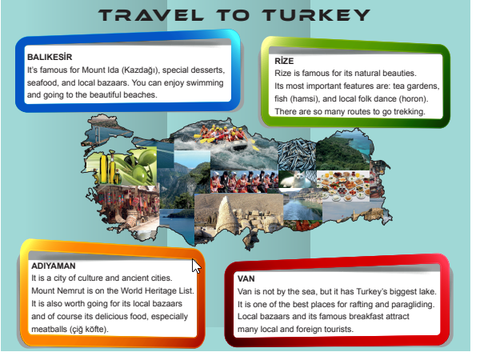(Meb Alıntı)
- Ada is interested in water and air sports; so he should g o to Van
- Cem likes watching traditonal dances; so he should g o to Rize
- Esra likes seaside holiday; so he should g o to Balıkesir
- Mert likes red meat. He should g o to Adıyaman
- If you like breakfast, you should g o to Van

- Read the text and fill in the chart according to the given information in the text (3x7=21 pts)
(Alıntı)
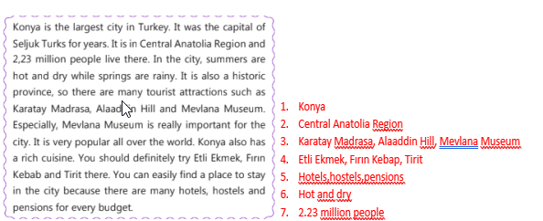
- Look at the chart and answer the questions (3pts:3x8=24 pts)

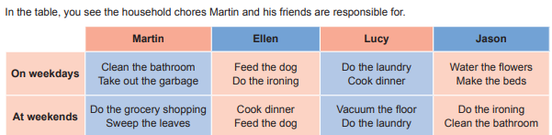Meb Alıntı
Meb Alıntı

- Lucy always do indoor chores
- Martin and Jason do garden chores
- Ellen _is responsible for the pet
- Martin_and Jason do the same bathroom chores
- Lucy_is in charge of preparing meals
- Martin’s duty is doing shopping

- Read the text and answer the questions. (5pts:5x4=20 pts)
Hi! I’m David. Everyone has different responsibilities in my family. For example, I’m responsible for making my bed, taking out the garbage and walking the dog for a walk. My father, Tom always does the grocery shopping, sets the table and loads the dishwasher after dinner every day. On weekends, he also sweeps the leaves in the garden and waters the plants. My mother cooks the meals and cleans the house except on Saturday and Sunday nights because she watches her favorite TV serials on these days. In my opinion, family members should share their responsibilities because this will make our lives easier

- Who is responsible for garden chores ?
Tom is responsible for garden chores
- What are David’s responsibilities ?
He is responsible for making his bed, taking out the garbage and walking the dog for a walk
- Does his mother do any chores at the weekend ?
No,she doesn’t
- Do all family members share the responsibilities ?
Yes, they do

5. Read the text and answer the questions (4pts:4x5=20 pts)(alıntı)

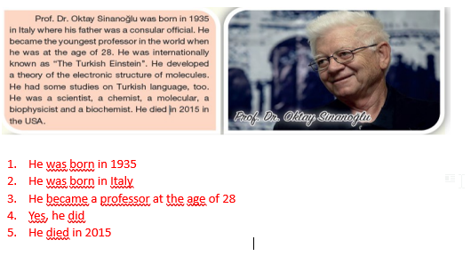
https://www.ingilizceciyiz.com/

