2025-2026 EDUCATIONAL YEAR ……………………….. SECONDARY SCHOOL
7th GRADE 2nd TERM 2nd WRITTEN EXAM
NAME-SURNAME:……………………………………CLASS:…………………NUMBER:………………GRADE:………

- Write about Mary and Daniel’s dreams about the future (5pts:5x6=30 pts)
2.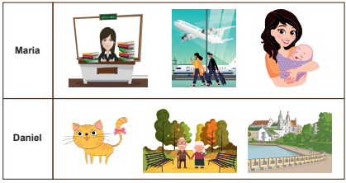(Meb alıntı)
a. Maria will g oto a good university
b.Maria will travel around the world
cMaria will get married and have a baby
d Daniel will adopt a pet
e Daniel will get retired
f-Daniel will live in a peaceful place
2.Read the text and answer the questions (5pts:5x6=30 pts)
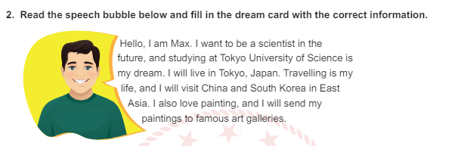
(Meb alıntı)

- What is Max’s dream ?
He wants to be a scientist
- Which university will he study?
He will study at Tokyo University of Science
- Where will he live ?
He will live in Tokyo, Japan
- Does he like travelling ?
Yes, he does
- Where will he visit ?
He will visit China and South Korea
- Does he like paintings ?
Yes, he does
3.Fill in the blanks with the appropriate word (3pts:3x5=15pts)
a. I went to the bakery to buy bread
b. I went to the movie theatre to watch a film
c. I went to the theatre to see a play
d. I went to the hospital to see the doctor
e. I went to the amusement park to have fun
- What should we do to protect the environment ? (4pts: 4X5 =20 pts)

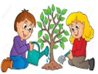 | We should plant trees
 | We should recycle paper, plastic and glass
 | We shouldn’t throw rubbish on the ground
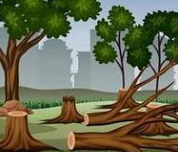 | We shouldn’t cut down trees
 | We should use public transportation

- Write about your future dreams (5pts)


https://www.ingilizceciyiz.com/

