2025-2026 EDUCATIONAL YEAR ……………………….. SECONDARY SCHOOL
6th GRADE 2nd TERM 2nd WRITTEN EXAM
NAME-SURNAME:…………………………………CLASS:…………………NUMBER:………………GRADE:………

- Look at the chart and answer the questions (5pts: 5x4=20pts)
 |  |  | 
Saturday | Emily | Lola | Tom ,Sally
Sunday | Sally | Tom | Lola

- Who went to the cinema on Saturday ?
Tom and Sally went to the cinema on Saturday
- When did Emily g oto the library ?
She went to the library on Saturday
- Did Lola do shopping on Sunday ?
No,she didn’t
- What did Tom do on Sunday ?
He did shopping

- Look at the graphic and fill in the blanks (3pts: 3X3= 9 pts)

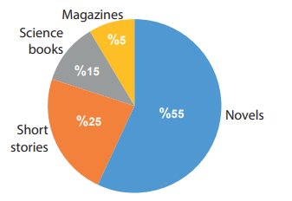
MEB BECERİ TEMELLİ S.

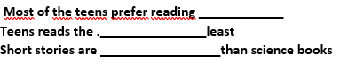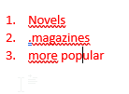

- Read the text and fill in the chart (5pts:5x4=20pts)

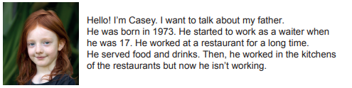MEB BECERİ TEMELLİ S.

- Casey’s father was born in nineteen seventy-three
- He first worked as a waiter
- He served food and drinks at a restaurant
- He isn’t working now. He is retired

- Write the places of the dog (3pts: 3x4=12 pts)
 | The dog is in the box
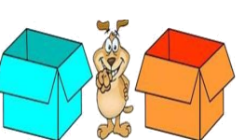 | The dog is between the boxes
 | The dog is behind the box
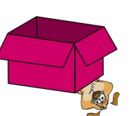 | The dog is under the box

- Write a short paragrapgh about Kemal Sunal (4pts: 4x5=20 pts)

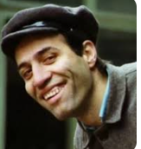 | Name: | Kemal Sunal
 | Date of birth | 11/10/1944
 | Place of birth | İstanbul
 | Occupation | actor
 | Famous Films | Hababam Sınıfı  Çöpçüler Kralı
 | Death | 3/07/2000

His name is Kemal Sunal. He was born on the eleventh of October, nineteen forty-four.He was born in İstanbul. He was an actor. His famous films were Hababam Sınıfı and Çöpçüler Kralı. He died on the third of July, two thousand . He died in İstanbul

- What should we do to protect the environment ? (4pts: 4X5 =20 pts)

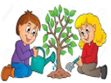 | We should plant trees
 | We should recycle paper, plastic and glass
 | We shouldn’t throw rubbish around
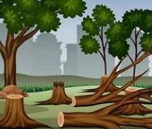 | We shouldn’t ct down trees
 | We should use public transportation

https://www.ingilizceciyiz.com/

