






Toplam Puan
..............

İNGİLİZCE 2. DÖNEM 2. YAZILI SINAVI

Adı: Soyadı: Sınıfı:

Soru
( Puan)
..................

Soru
( Puan)
..................

Soru
( Puan)
..................

Soru
( Puan)
..................

Soru
( Puan)
..................

Soru
( Puan)
..................

Soru
( Puan)
..................

Soru
( Puan)
..................

Kazanım: E6.5.R1. Students will be able to understand general meaning in simple texts related to the feelings and personal opinions about places and things.

- Read the conversation below and answer the questions.

What do you think about roller coasters?
I think they’re exciting!
I disagree.
I think they are dull.

Grace Lora Simon
  - Who likes roller coasters?
  - What does Simon think about roller coaster?

Kazanım: E6.6.W1. Students will be able to produce a piece of writing about occupations and the dates.

- Look at the visual below and write a short text including all the information on it.

Name Emma

Surname

Date of Birth

Place of Birth

Occupation
Watson

15th of April, 1990

Paris, France

Actress

6. sınıf
2024-2025

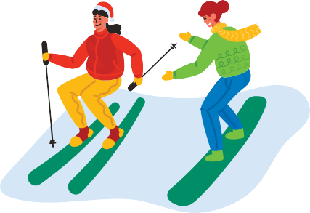
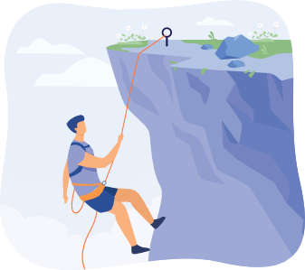
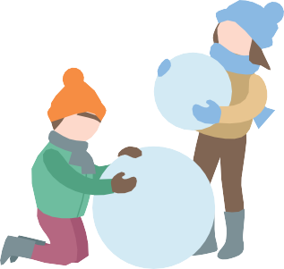
İNGİLİZCE
2. DÖNEM 2. YAZILI SINAVI Å

Kazanım: E6.7.R1. Students will be able to understand short, simple sentences and expressions related to past activities.

- Star Middle School asked 50 students about what they did last summer. Read the results below and label the slices of the pie chart.
- Five students visited their friends.
- Half of the students learned swimming.
- Twenty students went sightseeing.

:

:

:

Kazanım: E6.7.W1. Students will be able to write short and simple pieces in various forms about holidays.

- Look at the visuals below and write down what Cara did on her winter holiday.

6. sınıf



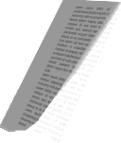


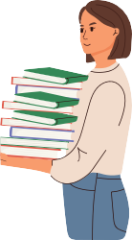
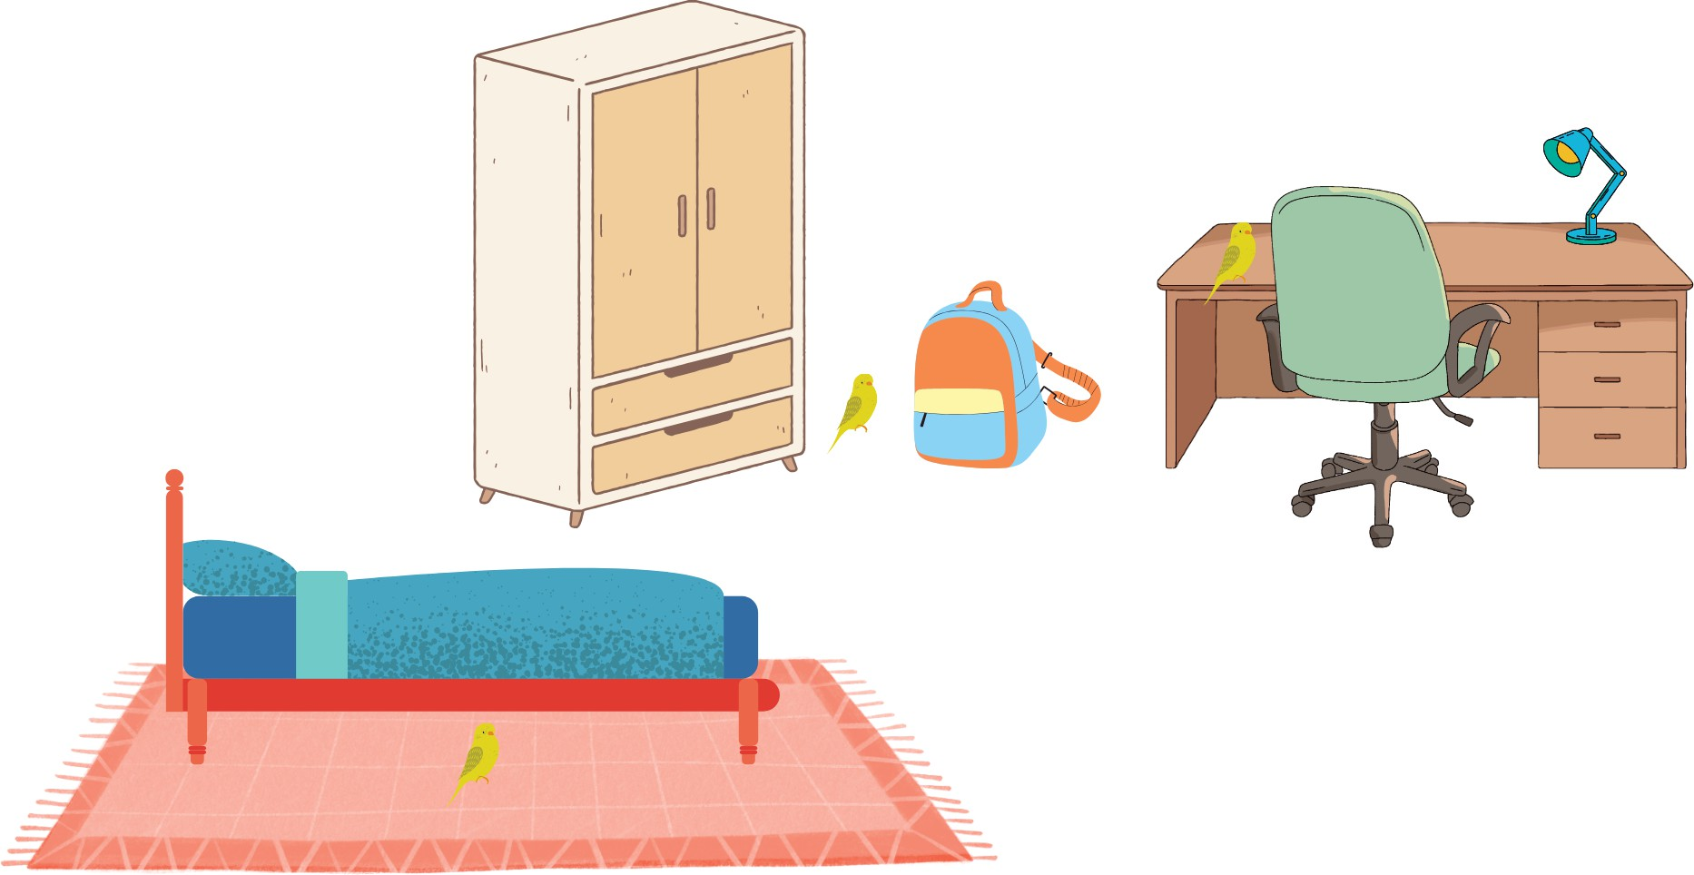
✓
2. DÖNEM 2. YAZILI SINAVI
İNGİLİZCE

Kazanım: E6.8.R1. Students will be able to understand short, simple sentences and expressions about past events with definite time.

- Look at the table and answer the questions.

Saturday Lara, Mirza Lara

Sunday Mirza Mirza

  - Who went to the cafe on Saturday?
  - When did Lara borrow books from the library?
  - What did Mirza do on Sunday?
  - Did Lara read e-book on Sunday?

Kazanım: E6.8.W2. Students will be able to write about the locations of people and things.

- Yesterday, Ömer's bird, Sky, was flying and hiding around the house.
Look at the picture and write where Sky was.

6. sınıf

İNGİLİZCE
2. DÖNEM 2. YAZILI SINAVI Å

Kazanım: E6.9.R1. Students will be able to understand the texts about the protection of the environment.

- Read the text and answer the questions.

Unfortunately, our planet has some serious problems. These are global warming and pollution. Global warming is the increase of the heat in the Earth's atmosphere. Most people use their private cars. Exhaust gases cause air pollution. People also pour their waste into the sea. It causes water pollution.
  - What are the problems of our planet?

  - What's global warming?

  - What's the reason for air pollution?

  - What's the reason for water pollution?

Kazanım: E6.9.W1. Students will be able to write simple pieces about the protection of the environment.

- Use the phrases below to write sentences with 'should' or 'sholdn't.'.
pollute the air
recycle batteries
unplug the TV
plant trees
waste water

SHOULD | SHOULDN'T
.

