____________________ SECONDARY SCHOOL 2025 -2026 EDUCATIONAL YEAR 2ND TERM 2ND WRITTEN EXAM FOR 5Th GRADES
Name - Surname: ANSWER KEY Class - Number:
(Senaryo 5)
1. Read the text and do the exercises.
I’m Asya. I live in a flat with my family in the city centre. There are two bedrooms, a sitting room, a kitchen, a bathroom and a balcony in our house. I have two bookcases, a wide bed, a desk and a wardrobe in my room. There is a comfortable sofa in our sitting room, and we watch TV here in the evenings. We usually have breakfast and dinner in the kitchen.
There are two schools, a sport centre, a museum, a park and a library in my neighbourhood. My friends and I go to the library to do our homework after school. My mum goes to the gym to do exercises every Saturday.

a. Write the names of the places according to the text above. 6x1=6P
1. Library 2. Gym 3. Museum 4. Kitchen 5. Bathroom 6. Bedroom
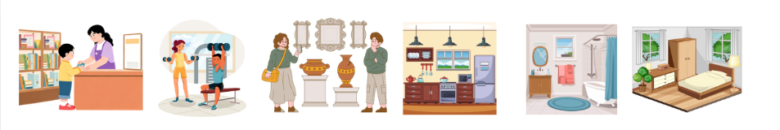

b. Answer the questions. 8x2=16P

1. Where does Asya live?
She lives in a flat in the city centre.
2. What does Asya do at the library?
She does her homework at the library.
3. How often does Asya’s mum go to the gym?
She goes to the gym every Saturday.
4. What does Asya and her family do in the sitting room?
They watch TV in the sitting room.

5. Where does Asya and her family have breakfast?
They have breakfast in the kitchen.
6. Why does Asya and her friends go to the library?
They go to the library to do their homework.
7. How many bookcases are there in Asya’s room?
There are two bookcases in her room.
8. Is there a museum in Asya’s neighbourhood?
Yes, there is.
2. Complete the sentences with “how many” or “how much”. 10x1=10P
1. How many beans are there on the plate?
2. How much milk do you need?
3. How much oil do you want?
4. How many nuts are there on the table?
5. How much flour do we add to make a cake?
6. How much cheese does she need to buy?
7. How many eggs do we need to make an omelette?
8. How many olives are there on top of the pizza?
9. How much water do you want?
10. How many tomatoes do you need?

3. Fill in the blanks with “have, haven’t, has or hasn’t” according to the pictures. 8x1=8P
1. Tom has got three bananas.
2. Ruth and Kate haven’t got any eggs in the fridge.
3. Tina has got two apples.
4. Ivy hasn’t got any milk.
5. Erica and Sue have got two bottles of water.
6. Vera hasn’t got any oranges.
7. Oliver has got some flour.
8. Den and Tim have got three lemons.




4. Read the text and do the exercises.
The blue whale is the largest mammal in the world. These blue-grey animals have a long body, a wide head, huge flippers, a powerful tail and a small fin. It lives in oceans and it can swim well. It eats small fish and krill. They travel to warmer waters to give birth. Blue whales live alone or in small groups. They can communicate with each other. They are very big and strong animals. They are good swimmers and they can stay under water for a long time. People must protect blue whales because they are rare today.

a. Match the underlined words with their definitions. 6x1=6P
1. communicate: to share information with others by speaking, moving your body, or using other signals
2. alone: without other people, there is no one with you
3. mammal: any animal of which the female feeds her young on milk from her own body
4. rare: not common or frequent; not seen often
5. protect: to keep someone or something safe from damage
6. tail: a part of an animal's body

b. Answer the questions.8x2=16P
1. What type of animal is a blue whale?
It is a mammal.
2. Where does it live?
It lives in oceans.
3. Has it got a tail?
Yes, it has.
4. What can it do?
It can swim well and communicate with other whales.
5. What can it eat?
It eats small fish and krill.
6. Is there any mammal larger than it?
No, there is not.
7. Why do they travel to warmer waters?
They travel to warmer waters to give birth.
8. Why do people protect them?
Because they are rare today.

5. Look at the pictures and complete comparative sentences using given adjectives. 8x1=8P
 | 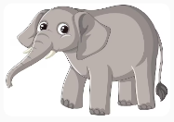 | 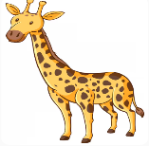 | 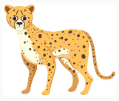
Height (cm) | 300 | 500 | 90
Weight (kg) | 5000 | 1000 | 120
Speed (km/h) | 30 | 60 | 100

1. The elephant is taller than the cheetah, but the giraffe is the tallest animal of all. (tall)
2. The giraffe is heavier than the cheetah, but the elephant is the heaviest animal of all. (heavy)
3. The giraffe is faster than the elephant, but the cheetah is the fastest animal of all. (fast)
4. The elephant is the biggest animal of all. (big)
5. The cheetah is shorter than the giraffe. (short)
6. Circle the correct answers. 5x1=5P
A crocodile, a snake and a lizard are wild / farm animals. They are insects / reptiles. Snakes and lizards live in forests, but crocodiles live in rivers / savannah. They eat small animals / plants. They can swim / fly.

7. Match the phrases with their halves. 6x1=6P 8. Circle the correct answer. 8x1=8P
d 1. ride a. a sandcastle
f 2. take b. the museum
a 3. make c. a sightseeing tour
e 4. have d. a camel
b 5. visit e. a picnic
c 6. join f. photos
I am going to visit / plan my grandparents in the village on half- term weekend / holiday. I am going to go / take hiking with my cousin, Tom, in the mountains / lakes. We are going to watch the view / tour when the sun rises.

9. Write a short paragraph about your dream holiday according to the questions above. 11P
I’m Tuna. I am going to go to Antalya on my summer holiday. I am going to stay in a cosy hotel. I am going to swim in the sea and make a sandcastle on the beach. I am going to see a tower, and I am going to visit a zoo to see my favorite animal, the monkey.

Students’ own answers
What are your plans?
What are you going to do there?
Which places are you going to see there?
Where are you going to go on your holiday?

