2025-2026 ACADEMIC YEAR ......................................................... SECONDARY SCHOOL
2nd TERM 2nd ENGLISH WRITTEN EXAM FOR 5TH GRADES
Name & Surname: Class: Mark:
Number: Date:

1. Read the dialogue and answer the questions. (4x5=20P)
1. Where is Mark now?
________________________________
2. Does he order a dessert?
________________________________
3. What does he eat?
_________________________________
4. What does he drink?
________________________________

Waiter :What would you like as a main dish?
Mark :Grilled fish with mashed potato.
Waiter :Would you like something to drink?
Mark :Fruit juice, please. Do you have dessert?
Waiter :Yes, sir. Apple tart and pudding?
Mark :A piece of apple tart, please.
Waiter :Sure.


2. The table below shows some wild animals and their abilities. Write at least four sentences with using CAN or CAN’T. (4x5=20P)
______________________________________________________________________________________________________________________________________________________________________________________________________________________________________________________________________________________________________________________________________________________________________________________________________________________________________________
Animals and their abilities |  | 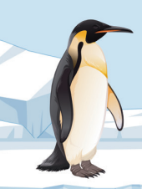 | 
jump
fly
run
3. Read the text and fill in the table. (5x4=20P)

Sharks are among the most dangerous wild animals. They live in the ocean and they are big fish. They have sharp teeth and fins. They can eat other sea animals. They can see well in dark
Type | Body parts | Habitat | Food | Abilities
_____________ | _____________ | ____________ | ___________ | _______________
4. Look at the table and write the correct days under the pictures. (5x4=20P)
Jessica’s plans for next week are below.
Monday | Tuesday | Wednesday | Thursday | Friday
Collecting seashells | Sunbathing | Making a sandcastle | Snorkeling | Swimming

 |  | 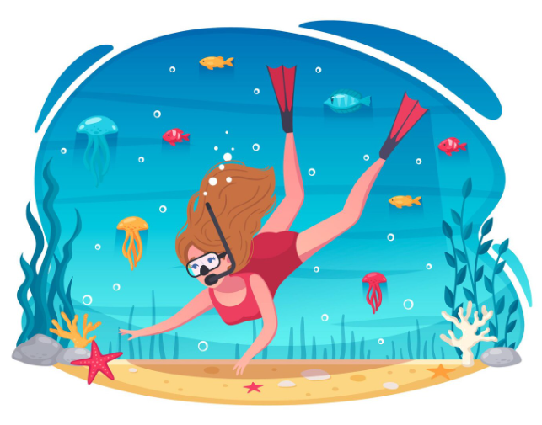 |  | 
______________ | ______________ | ______________ | ______________ | ______________
5. Read the dialogue and write the names of students under the correct pictures. (4x5=20P)
Esra: I like going to the zoo.


Duygu: I like going to the historic places.
Özlem: I like going to the amusement park.
Seda: I like going to the valley.
What is your favorite holiday place?
 | 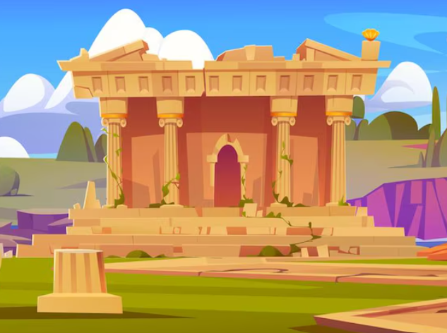
__________________________________ | __________________________________
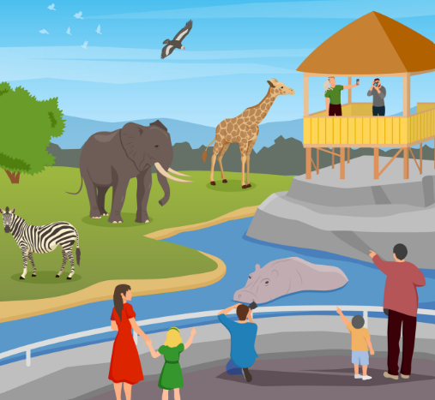 | 
__________________________________ | __________________________________
https://www.ingilizceciyiz.com/

