2025-2026 EDUCATIONAL YEAR ……………………….. SECONDARY SCHOOL
8th GRADE 1st TERM 2nd WRITTEN EXAM
NAME-SURNAME:…………………………………………………CLASS:…………………NUMBER:………………GRADE:………

- Write the words into the correct column (1 pts: 1x20=20 pts)
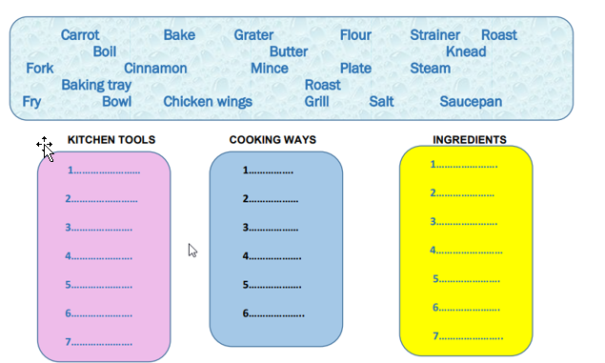

- Look at the pictures and write the appropriate word (2pts:2x10=20pts)

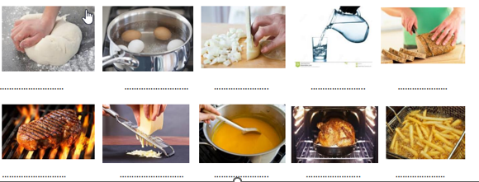

- Read the text and use linkers: finally,next,then,second,after that,first (3pts:3x6=18pts)

 | Here is the recipe of popular dish in Turkey  …………………….., chop some onion and gren pepper. ………………………., peel some tomatoes and chop them,too. ……………………… heat some olive oil in a frying pan and put the mixture into pan. ……………………….cook the mixture nearly 15-20 minutes ……………………..crack the eggs into the pan and add salt,chilli pepper ………………………  turn off the heat when the eggs are cooked.Serve it hot!

- Read the phone conversation and answer the questions (5pts:5x3=15pts)
David: Hi, David is speaking. Is Sarah there?
Lisa : Hi, David. She isn’t available now. Would you like to leave a message?
David:Yes. Can tou tell her to call me back as soon as possible ?
Lisa: Ok
- Who calls Sarah ?
_____________________________________________
- Is Sarah available ?
_____________________________________________
- Does David leave a message ?
____________________________________________

- . Read the situations and answer the questions.(5pts:5x3=12 pts)

- You are talking to a friend on the phone, but you can’t hear her.. What would you say?
__________________________________________________________________________

- One of your friends invites you to the party on the phone, but you are busy. What would you say?
__________________________________________________________________________
- You call your friend but she isn’t at home now. You want to leave a message. What would you say ?
____________________________________________________________________

- . Read the phone conversation below and complete the table. (3pts:3x4=12pts)
Brenda: Hi, Jane How are you?
Jane: Thank you,
Brenda. What about you?
Nancy: Fine. We are planning a surprise party for Eric at Rose Cafe at 3 pm on Sunday.. Would you like to join us?
Lily: I am really busy, but I will be there. I don’t know where the café is. Can you text me its address, please?

Event
Place
Day
Organiser

Güncel Türkçe Matematik Fen Bilimleri Sosyal Bilgiler ve Din Kültürü Yazılıları İçin www.fenbilimleri.net’i Ziyaret Edebilirsiniz

