… EDUCATIONAL YEAR … SECONDARY SCHOOL
1ST TERM 2ND INDIVIDUALIZED WRITTEN EXAM FOR 7th GRADE

NAME-SURNAME:
CLASS-NUMBER: 7/

A- Hayvan resimlerinin altına isimlerini yazınız. (40p)
- Lion – Zebra – Elephant – Horse - Gorilla – Panda – Giraffe – Tiger

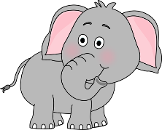 | 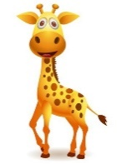 |  | 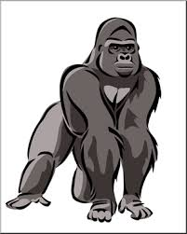
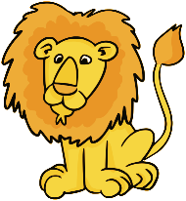 | 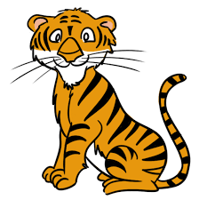 |  | 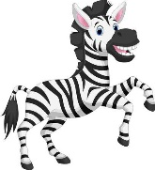

B- Yılları okunuşlarıyla eşleştiriniz (20p)
1. 2024 (…..) a) Nineteen oh eight
2.1908 (…..) b) Seventeen Fifty
3. 1750 (…..) c) Eighteen eighty one
4. 1881 (…..) d) Twenty twenty four

C- Sporları uygun kategorilere yerleştiriniz. (24p)
basketball / football / tennis / volleyball / swimming / hiking

Team Sports (Takım Sporları)
Indiviual Sports (Bireysel Sporlar)

D- Doğru seçeneği işaretleyiniz. (16p)

1- Atatürk was born in ________________ .
a) 1881 b) 1832

2- a) She has got short hair.

b) She has got long hair.

3- What equipment do you need to play tennis?
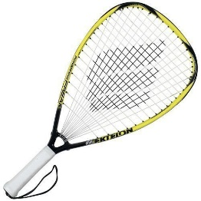

a) b)

4- 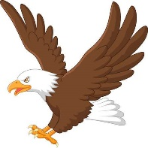 are endangered animals.

a) eagles b) elephants

https://www.ingilizceciyiz.com/

