2025-2026 EDUCATIONAL YEAR ……………………….. SECONDARY SCHOOL
7th GRADE 1st TERM 2nd WRITTEN EXAM
NAME-SURNAME:…………………………………………………CLASS:…………………NUMBER:………………GRADE:………

- Read the text and answer the questions (5pts:5x6=30 pts)

((Meb Alıntı)

Name:
Date of Birth:
Place of birth:
İnvention:
Date of death:
Place of death:

- Read the information and answer the questions (5pts:5x4=20 pts)

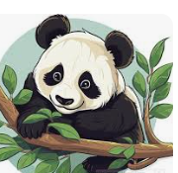 | Name: Panda  Kind: Mammal  Habitat: Bamboo Forests  Life-Span: 30 years  Diet: Bamboos

- What kind of animal is it ?
____________________________________________________
- Where does it live ?
____________________________________________________
- How long does it live ?
___________________________________________________
- What does it eat ?
__________________________________________________

- Read the text and answer the questions (4pts:4x5=20 pts)

 | This is my grandmother, Tom. He was born on  12 October, 1948, Ankara . He was a lawyer. He grew up in Ankara.He graduated from the university in 1971. He is retired now.

- When was Tom born ?
_____________________________________________________
- Where was Tom born ?
_____________________________________________________
- How old is he now ?
____________________________________________________
- What was his occupation ?
___________________________________________________
- Is he working now ?
___________________________________________________
- Read the text and answer the questions (5pts:5x3=15 pts)


Sally enjoys doing different kinds of sports, but her favourite one is archery . She needs to have some special equipment to do this sport such as an arrow and a bow . She does training every day

a. What is Sally’s favourite sport?
______________________________________________________

b. Which equipment does Jane need to do her favourite sport?
________________________________________________________

c. How often does she do training ?
____________________________________________________

- What should we do to protect the wildlife ? Write at leat 3 sentences.(5pts:5x3=15 pts)
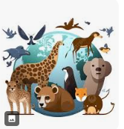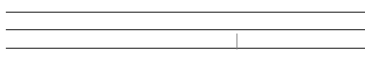

Güncel Türkçe Matematik Fen Bilimleri Sosyal Bilgiler ve Din Kültürü Yazılıları İçin www.fenbilimleri.net’i Ziyaret Edebilirsiniz

