Cebrail Hocam Secondary School 7th Grades 1st Term 1st Written Exam

Name – Surname: Teacher Zehra Class: 7/A Number: 300
1) Read the boxes and answer the questions. (K.E7.1.R1.) (4x2=8pts)
- Who is honest?
Janet
- Who is selfish
Arthur
He always comes to school on time. He is never late.
Stephan
She never tells lies and always tells the truth.
Janet
He likes meeting with new people and making friends.
Martin
He never minds other people. He only thinks of himself.
Arthur

- Who is outgoing?
Martin
- Who is punctual?
Stephan

2) Read the questions and answer 4 of them according to yourself by using frequency adverbs ‘always, usually, often, sometimes, rarely, never.’ (K.E7.2.W1.) (4x4=16pts)

- I usually wake up at seven o’clock.
- I always go to school on foot/by car/ by bus.
- I often take a rest after school.
- I usually read a book/ watch tv/ keep a diary in the evenings
- I usually do exercise/go jogging in the park.
- I sometimes hang around with my friends.
- I sometimes go to the cinema with my friends and surf the Internet.
- I rarely go to bed late, I usually go to bed at ten o’clock.

1) What time do you wake up in the morning?
2) How do you go to school?
3) What do you do after school?
4) What do you do in the evenings?
5) How often do you do a sport /do exercise?
6) How often do you hang around /go outside with your friends?
7) What do you do at weekends?
8) What time do you go to bed at nights?

3) Read the text and answer the questions. (K.E7.3.R1.) (5x4=20pts)
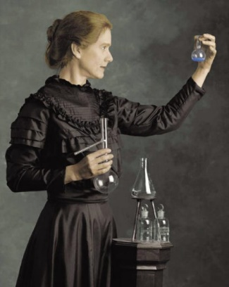
Marie Curie was an important scientist. She was born on 7 November 1867 in Warsaw, Poland. She studied physics and mathematics at the university and was very interested in science. She moved to France to continue her education.
She discovered two new elements, polonium and radium, with her husband Pierre Curie. She did important studies on radioactivity. She won the Nobel Prize in Physics in 1903 and the Nobel Prize in Chemistry in 1911. She was the first woman to win a Nobel Prize and the first person to win the Nobel Prize twice. Marie Curie changed the history of science. She died on 4 July 1934, at the age of 66.

d) What did she win in 1903 and 1911?
She won the Nobel Prize in 1903 and in 1911.
e) When did she die?
She died on the fourth of July in nineteen thirty four.

a) Where was Marie Curie born?
She was born in Warsaw.
b) What did she study at the university?
She studied physics and mathematics at the university.

c) Why did she move to France?
She moved to France to continue her education.

4) Write 4 sentences about Barış Manço’s life with the given information in the table. (K.E7.3.W1) (5x4=20pts)
1) He was born in nineteen fourty three.
2) He got married to Lale Çağlar in nineteen seventy eight.
3) He moved to Belgium in nineteen sixty three.
4) He graduated from Royal Academy in nineteen sixty nine.
5) He died in nineteen ninety nine.

Barış Manço | Year
be born | 1943
get married to Lale Çağlar | 1978
move to Belgium | 1963
graduate from Royal Academy | 1969
die | 1999
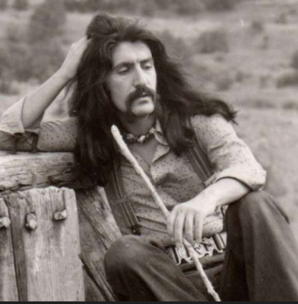

5) Read the text and do the activities. (K.E7.4.R1)

Whales are mammals. They are very large animals that live in the seas and oceans. They have big bodies, strong tails, and smooth skin. They breathe air through a blowhole on the top of their heads.
Their habitat is very important for their survival. Some whales eat small fish and krill.
Whales can live for a long time. Many whales live about 40–70 years. They are social animals and usually live in groups called ‘pods’. Baby whales stay close to their mothers and drink milk. Whales are intelligent and peaceful animals, and they are an important part of ocean life.
The number of whales decreased in the last century because people hunted them for their oil, meat, and bones. Also, water pollution, plastic waste, and oil spills harmed their habitats. People still continue to pollute the water and it’s really hard for them to find food and stay healthy. Protecting the oceans is very important for their survival.
5.a. Fill in the table according to the text. (5x2=10pts)

5.b. Answer the questions according to the text.
(2x5=10pts)

a) How do whales breathe?
They breathe air through a blowhole on the top of their heads.
b) Why did the number of whales decrease in the last century?
The number of whales decreased in the last century because people hunted them for their oil, meat, and bones.

Name | Whales
Kind | Mammal
Habitat | In the seas and oceans
Life span | 40-70 years
Diet | Carnivores

6) Look at the table and write 4 sentences about the animals. (K.E7.4.W1) (4x4=16)

 | Peregrine Falcon | Fruit Bat
Kind | bird | mammal
Habitat | mountains, cliff, cities | tropical forests, swamps
Diet | carnivore (other birds) | herbivore (fruit, nectar)
Life span | 12–15 years | 15–20 years
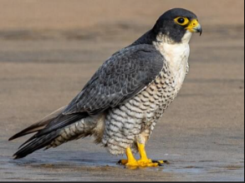
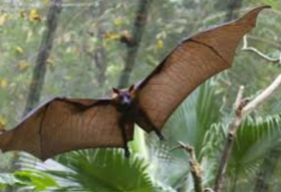

Fruit Bats are mammals.
They live in the tropical forests and swamps
They are herbivore. (They eat fruit and nectar.)
They live about fifteen to twenty years.
Peregrine Falcons are birds.
They live in the mountains, cliff and cities.
They are carnivores. They eat meat.
They live about twelve to fifteen years.

Not: Cebrail Hocam YouTube kanalında çözümleri vardır.

