………………………...................ORTAOKULU
7.
SINIF
PUAN:
Adı ………………………………………………
sb
İNGLİZCE Soyadı …………………………………………
1. DÖNEM 2. YAZILI SORULARI Sınıfı …………………. No …………………. ………………
1. Soru  (14 Puan) | 2. Soru  (16 Puan) | 3. Soru  (15 Puan) | 4. Soru  (15 Puan) | 5. Soru  (16 Puan) | 6. Soru  (12 Puan) | 7. Soru  (12 Puan) | Aldığı  Puan
………… | ………… | ………… | ………… | ………… | ........... | ........... | …….

S1
Read the text and answer the questions.
I have two classmates. Their names are Emma and Lisa.
Emma is tall and slim. She has got long curly hair and she always smiles. She is very talkative and outgoing, so she has a lot of friends.
Lisa is shorter than Emma. She has got straight dark hair and glasses. She is quiet but very helpful. She always does her homework carefully and helps her friends with their projects.
a. Who is quiet but very helpful?
✎_ _ _ _ _ _ _ _ _ _ _ _ _ _ _ _ _ _ _ _ _ _ _ _ _ _ _ _ _ _

b. Who is taller, Emma or Lisa?
✎_ _ _ _ _ _ _ _ _ _ _ _ _ _ _ _ _ _ _ _ _ _ _ _ _ _ _ _ _ _

c. Who has got long curly hair?
✎_ _ _ _ _ _ _ _ _ _ _ _ _ _ _ _ _ _ _ _ _ _ _ _ _ _ _ _ _ _

S2
Read the sentences below and complete the table with the names of the people or sports. Write only one sport or name for the titles.
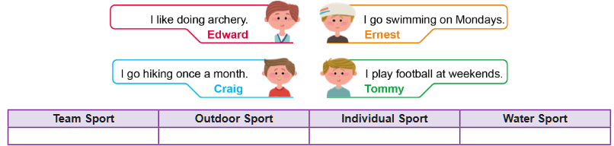

S3
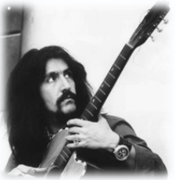
Read the conversation and write questions for the answers.
Stacy : What is his name?
April : He is Barış Manço.
Stacy : 1. ………………………………….....………………….………..……?
April : He was born in İstanbul.
Stacy : 2. ……………………………………….....…………….………..……?
April : He died in 1999.

S4
Look at the visual and write down a short paragraph about Marie Curie including all the given information.
Date of birth | Place of birth | Education | Awards | Job
November 7th, 1867 | Warsaw, Poland | • Studied physics and mathematics at the University of Paris  • Graduated as a top student | • Two Nobel Prizes for her work on radioactivity | Physicist and chemist in Paris
✎...

S5
Read the text and answer the questions.
Sea turtles are ancient animals. They have lived in the oceans for millions of years. Today, many sea turtles are endangered. They lay their eggs on sandy beaches at night. People build hotels on these beaches and leave rubbish in the sea, so baby turtles cannot reach the water easily and many of them die.
a. Where do sea turtles lay their eggs?
✎_ _ _ _ _ _ _ _ _ _ _ _ _ _ _ _ _ _ _ _ _ _ _ _ _ _ _ _ _ _

b. Why are many sea turtles endangered today?
✎_ _ _ _ _ _ _ _ _ _ _ _ _ _ _ _ _ _ _ _ _ _ _ _ _ _ _ _ _ _

S6
Read the text and answer the question.
Last weekend, my family and I went to a big zoo. At the entrance, we saw some cows and goats from a small farm. Then we walked to the safari area and watched lions sleeping under a tree. Near the river, there were tall giraffes eating leaves and zebras walking on the grass. We also saw two elephants playing with water and some monkeys jumping from tree to tree.
Which animals in the text are wild animals? Write their names.
✎ ......

S7
Look at the table below and write down a short paragraph including at least four sentences about giant pandas.
Name | Giant Panda
Colour | Black and white
Size / Weight | About 1–1.5 meters long / 70–120 kg
Habitat | Mountain forests in China
Diet | Mostly bamboo, sometimes other plants
Interesting Facts | • Spend many hours a day eating bamboo
 | • Good climbers
 | • Baby pandas are very small at birth
✎ Write your paragraph here:

