2025-2026 EDUCATIONAL YEAR ……………………….. SECONDARY SCHOOL
6th GRADE 1st TERM 2ND
WRITTEN EXAM
NAME-SURNAME:…………………………………………………CLASS:…………………NUMBER:………………GRADE:………

- Read the text and fill in the blanks. (1pts:1X10:10 pts)

I don’t like living in a 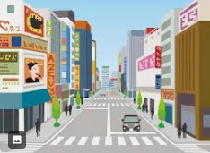……………………………… . The downtown is always noisy and ………………………………. There is always a 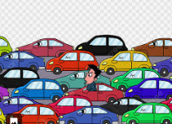…………………………….. There are a lot of  …………………………..

But living in a 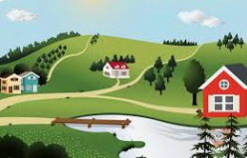 ……………………………..is more peaceful and relaxing. It is quiter than the downtown. The air is cleaner. I like countryside.

- Make comparisions between Melisa and Joe. Write at least 3 sentences (3pts:3X3= 9 pts)

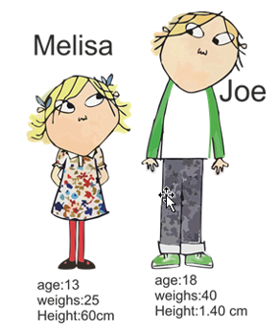

- Look at the visuals and answer the questions (3pts:3x4=12pts)

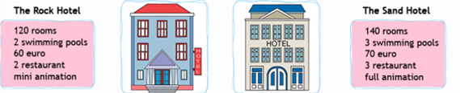

- Which hotel is larger ? _____________________________________________
- Is Rock Hotel more enjoyable than the Sand Hotel ? _____________________________
- Which hotel is more expensive ? ____________________________________________
- Is the Rock hotel smaller than the Sand Hotel ? __________________________________

4.Read the text and answer the questions (3pts:3x5=15 pts)
Hi, I'm Cindy. I live in a big city. I love living here. The buildings are higher in big cities than in small towns. There are a lot of skyscrapers and shopping centers. You can g o shopping. There are a lot of places to go. Life is more enjoyable than small towns. I think living in a small town is boring
Hi. I’m Martin. I live in a village. Living in a village is quiet and relaxing. The streets are clean. I don’t like cities. They are more crowded and noisier than villages. There is always a traffic jam. Big cities are more expensive than towns. I think cities are dangerous

- Who prefers living in a village ? _________________________________________________
- Does Cindy like city life ? _________________________________________________
- What does Martin think about cities ? _________________________________________________
- Are there skyscrapers in villages ? ________________________________________________
- Which one is more expensive? Cities or villages ? _______________________________________

- Look at the Picture and write what they are doing now (3pts:3x5=15pts)

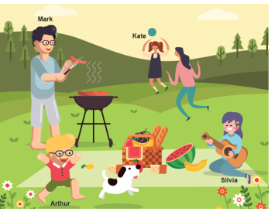

- Look at the visual and fill in the blanks (2pts:2x5=10 pts)

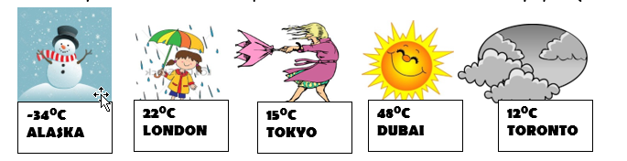

News Reporter: : Good morning! Let’s see how the weather is today. In Dubai, it is hot and -----------------. In London, the weather is -----------------------------------and warm. . In Toronto, it is ……………………… In Alaska the temperature is …………………………..and it is freezing. London is ………………………than Tokyo.

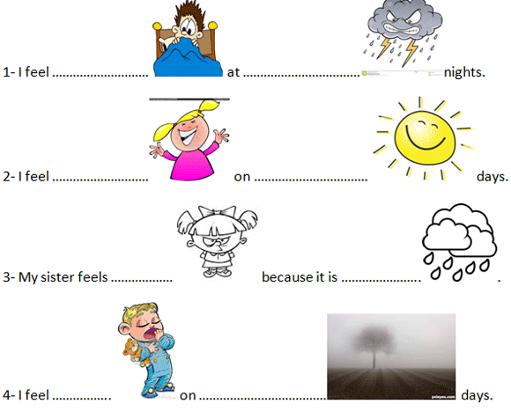
- Look at the visual and fill in the blanks (1pts:1x8=8 pts)

- Read the text and answer the questions (3pts:3x7=21 pts)

Hello! I am Ada. Today is Sunday and we are having a picnic at my grandparents’ farm house . The weather is sunny so I feel happy. My father is preparing the barbeque and my mother is helping him. My mother is younger than my father. My sister and I are setting the table. My sister’s name is Emel. She is fatter than me. I am taller than her. My younger brother Cem is riding a horse now. Our dog is running with them.. My grandfather is reading a newspaper. He likes reading a newspaper. My grandmother is knitting at the moment. I love my family very much.

- What are they doing ? ______________________________________________________
- What is the weather like ? ______________________________________________________
- How does Ada feel ? _____________________________________________________________
- Who is preparing the barbecue ? __________________________________________________
- Is Ada thinner than Emel ? _____________________________________________________
- Is Cem older than AdA? ____________________________________________________
- What is her grandmother doing now ? ______________________________________________
- Güncel Türkçe Matematik Fen Bilimleri Sosyal Bilgiler ve Din Kültürü Yazılıları İçin www.fenbilimleri.net’i Ziyaret Edebilirsiniz

