………………………...................ORTAOKULU
6.
SINIF
PUAN:
. Adı ………………………………………………
sb
İNGLİZCE Soyadı …………………………………………
1. DÖNEM 2. YAZILI Sınıfı …………………. No …………………. ………………
1. Soru  (12 Puan) | 2. Soru  (12 Puan) | 3. Soru  (15 Puan) | 4. Soru  (20 Puan) | 5. Soru  (15 Puan) | 6. Soru  (12 Puan) | 7. Soru  (16 Puan) | Aldığı  Puan
………… | ………… | ………… | ………… | ………… | ........... | ........... | …….

S1
Read the text and answer the questions.
Mia is a young tennis player. She gets up at seven o’clock and has breakfast at half past seven. She usually eats wholegrain bread, cheese, tomatoes and an apple. She sometimes has eggs, too. Her favourite food for breakfast is tomatoes because they are fresh and tasty. She always drinks orange juice in the morning because it is full of vitamins.
A. What does Mia eat for breakfast?
......................................................................................................................
B. Is her breakfast healthy or unhealthy?
......................................................................................................................
C. What is her favourite food for breakfast?
......................................................................................................................
D. Does she drink orange juice in the mornings?
......................................................................................................................

S2
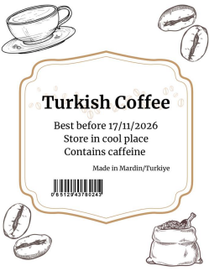
Look at the label of the product and answer the questions
a- What is the name of the product?
✎...

b- What is the date marking?
✎...

c- What is the country of origin?
✎...

d- What is the direction for using?
✎...
S3
Read the sentences and write down the names of the countries in the correct places.
• Russia is larger than France and Germany.
• Germany is smaller than France.
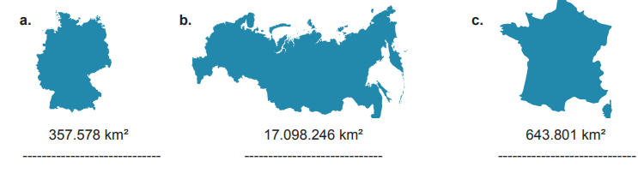
S4
Look at the table and write 3 sentences comparing the cities according to the given information
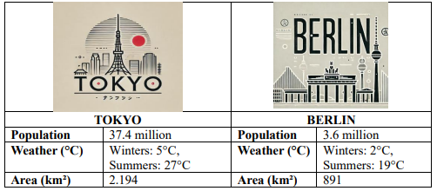
a) ..........................................................(crowded) b) ......................................................... (big)

c) .......................................................... (hot) d) .......................................................... (cold)

S5
Read the statements and complete them with suitable words. The first letter of each word is given!
a. Sally goes outside and plays with water on rainy days, so she feels h------------------------------ and e-------------------------------------- on these days.
b. Olivia loves watching snowfalls and drinking hot chocolate, so her favourite season is w--------------------------------------------.
c. Emma loves reading books and enjoys the cool weather, so she feels r---------------------------------------- in autumn.
d. Jack is afraid of thunder and lightning, so he feels s-------------------------------- on stormy days.
S6
Look at the visuals and complete the blanks with the correct weather conditions and feelings.
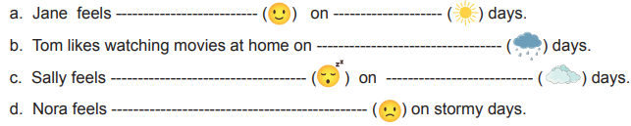
S7
Read the text and answer the questions.
Dear Lisa,
You wrote that it is always hot and dry in Dubai. That is very interesting for me because we have different seasons here in Erzurum, Türkiye.
In winter, the weather is very cold and snowy. I go skiing with my friends and make a snowman. I feel excited and happy in this season. In spring, it is warm and sometimes rainy. The trees become green again. On rainy days I feel relaxed and I like listening to the rain. In summer, the weather is hot and sunny. We have picnics by the river and eat ice cream. I feel energetic and I stay outside all day. In autumn, it is cool and windy. The leaves turn yellow and fall. I sometimes feel a little sad because the days get shorter. I hope you can visit Erzurum one day. Then you can see the snow in winter and enjoy the cool weather in autumn with me.
Best wishes, Mert

a. What is the weather like in winter in Erzurum?
✎...
b. How does Mert feel in summer?
✎...
c. In which season does Mert sometimes feel sad?
✎...
d. What is the weather like in Dubai?
✎...

