………………………...................ORTAOKULU
6.
SINIF
PUAN:
. Adı ………………………………………………
sb
İNGLİZCE Soyadı …………………………………………
1. DÖNEM 2. YAZILI Sınıfı …………………. No …………………. ………………
1. Soru  (16 Puan) | 2. Soru  (12 Puan) | 3. Soru  (12 Puan) | 4. Soru  (16 Puan) | 5. Soru  (14 Puan) | 6. Soru  (15 Puan) | 7. Soru  (15 Puan) | Aldığı  Puan
………… | ………… | ………… | ………… | ………… | ........... | ........... | …….

S1
Look at the visual and complete the blanks with the correct information.

Zury is a giraffe. He lives in a town. Zury ............................................ at nine am. He wears his clothes at........................................... He meets his friends at a café at ........................................... .......................................... at quarter past seven pm.
S2
Write the names of the people under the pictures according to the text.
Hi, my name is Mehmet. I like having breakfast at weekends with my family. I like drinking tea at breakfast but my brother Ahmet likes drinking milk. My mother, Meryem prefers eating cheese and eggs. My father, Onur likes eating sausages. My sister, Pelin prefers honey at breakfast.
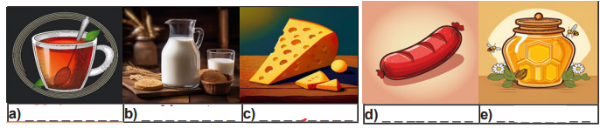
S3
Look at the visual and answer the questions

What is the date marking?
✎_ _ _ _ _ _ _ _ _ _ _ _ _ _ _ _ _ _ _ _ _ _ _ _ _ _ _

What is the name of the food?
✎_ _ _ _ _ _ _ _ _ _ _ _ _ _ _ _ _ _ _ _ _ _ _ _ _ _ _

What are the ingredients?
✎_ _ _ _ _ _ _ _ _ _ _ _ _ _ _ _ _ _ _ _ _ _ _ _ _ _ _

S4
Write down what Tom and his family members are doing now according to the visuals.
Today is Sunday. Tom is spending time with his family in a park


a. Tom ------------------------------------------------------
b. His sister, Lily, -----------------------------------------
c. His cousins ---------------------------------------------
d. His mum, Rachel, ------------------------------------
S5
Look at the table and answer the questions.
 | Konya, Türkiye | Dublin, Ireland
Population | 2,250,000 | 550,000
Weather (°C) | 18 °C | 12 °C
Area (km²) | 38,873 | 118
a. Which city is more crowded?
✎.............................................................................
b. Which city is hotter?
✎.............................................................................
c. Is Konya larger than Dublin in area?
✎.............................................................................

S6
Answer the questions about yourself.
a. What is the weather like in spring in your hometown?
✎...
b. How do you feel on sunny days?
✎...
c. What do you do on rainy days?
✎...
S7
Complete the text according to the table.
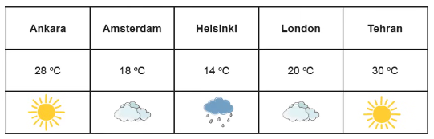
News Reporter: Good morning! Let’s see how the weather is today. In Ankara, it is hot and -----------------. In Amsterdam and London, the weather is -----------------------------------. Helsinki is ------------------------------- than Amsterdam, and it is --------------------------. Tehran is -----------------------------------than Ankara.

