S1
Zury is a giraffe. He lives in a town. Zury wakes up/gets up at nine am. He wears his clothes at twenty past nine am/nine twenty am. He meets his friends at a café at half past three pm/fifteen thirty. He takes a shower/has a shower at quarter past seven pm.

S2
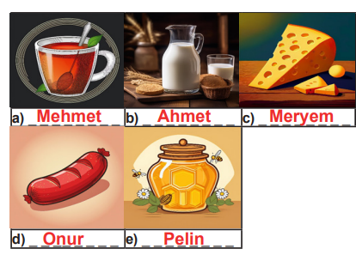

S3
What is the date marking?
➜ Best Before 20.04.2023
What is the name of the food?
➜ Chocolate Cookies
What are the ingredients?
➜ Flour, baking soda, water and cocoa bars

S4
a. Tom is riding a bike.
b. His sister, Lily, is flying a kite.
c. His cousins are skipping rope / are jumping rope.
d. His mum, Rachel, is reading a book.

S5
a. Konya is more crowded than Dublin.
b. Konya is hotter than Dublin.
c. Yes, it is. Konya is larger than Dublin in area.

S6
a. What is the weather like in spring in your hometown?
✎ It is usually warm and sometimes rainy in spring in my hometown.
b. How do you feel on sunny days?
✎ I feel happy and energetic on sunny days.
c. What do you do on rainy days?
✎ I usually stay at home, read books and watch TV on rainy days.

S7
