………………………...................ORTAOKULU
6.
SINIF
PUAN:
. Adı ………………………………………………
sb
İNGLİZCE Soyadı …………………………………………
1. DÖNEM 2. YAZILI Sınıfı …………………. No …………………. ………………
1. Soru  (16 Puan) | 2. Soru  (12 Puan) | 3. Soru  (12 Puan) | 4. Soru  (16 Puan) | 5. Soru  (14 Puan) | 6. Soru  (15 Puan) | 7. Soru  (15 Puan) | Aldığı  Puan
………… | ………… | ………… | ………… | ………… | ........... | ........... | …….

S1
Read the text and answer the questions.
Hello! My name is Julia. I’m 11 years old. I usually get up at 7 am on weekdays. I always have breakfast at 7:30 am. My father drives me to school at 8 am. My classes start at 8:30 am. I have lunch at 12:30 pm in the school canteen. My classes finish at 3:30 pm, and I come back home at 4:00 pm. I play tennis with my friends at 4:30 pm.
a. What time does Julia get up on weekdays?
✎...
b. Does Julia have lunch at school?
✎...
c. What does Julia do after school?
✎...
d. Does Julia walk to school?
✎...

S2
Read the students’ breakfast preferences and write their names under the correct breakfast set.
Adam: I prefer milk to orange juice at breakfast
Lisa: I don’t prefer healthy food.
Jack: I have cheese, olives and cucumber for breakfast.
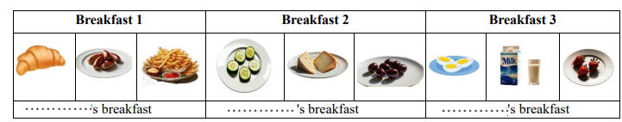

S3
You should eat fruit and vegetables every day because they are healthy.
Write down three examples of healthy foods.
❖

❖

❖

S4
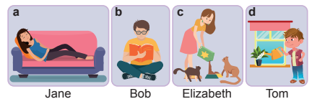
I. Elizabeth is feeding her pet.
II. Tom is watering the flowers right now.
III. Jane is taking a nap at the moment.
IV. Bob is reading a book.
Match the images with the descriptions.

a: ................. b: ............................ c: .......................d: ........................
S5
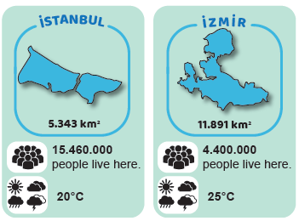
Look at the picture. Compare İstanbul and İzmir.
A) Which city is bigger in area and which city is more crowded? Write in a sentence.
✎...

B) How is the weather in İstanbul and İzmir? Which city is hotter today? Explain.
✎...

S6
Answer the questions about yourself.
a. What is the weather like in spring in your hometown?
✎...
b. How do you feel on sunny days?
✎...
c. What do you do on rainy days?
✎...
S7
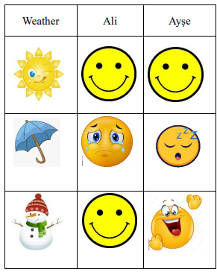
The students are talking about their feelings. The following chart shows their feelings about different weather conditions
Look at and read the chart and write down the feelings of the students.
a. Ayşe is ................................... on snowy days.

b. Ayşe and Ali are ........................ on sunny days.

c. Ayşe is .............................. on rainy days.

