S1
a. She gets up at 7 am on weekdays.
b. Yes, she does. She has lunch at school in the canteen.
c. She plays tennis with her friends after school.
d. No, she doesn’t. Her father drives her to school.

S2
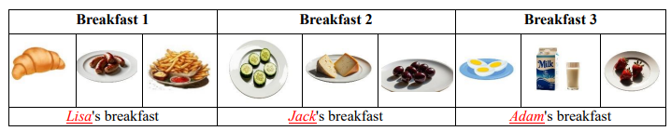

S3
❖ Apples
❖ Carrots
❖ Broccoli
S4 – Match the images with the descriptions
a: III. Jane is taking a nap at the moment.
b: IV. Bob is reading a book.
c: I. Elizabeth is feeding her pet.
d: II. Tom is watering the flowers right now.

S5 –
a- İzmir is bigger in area, but İstanbul is more crowded.
b- The weather is 20°C in İstanbul and 25°C in İzmir, so İzmir is hotter than İstanbul today.

S6
a. What is the weather like in spring in your hometown?
✎ It is usually warm and sometimes rainy in spring in my hometown.
b. How do you feel on sunny days?
✎ I feel very happy and energetic on sunny days.
c. What do you do on rainy days?
✎ I usually stay at home, read books and watch movies on rainy days.

S7
a. Ayşe is happy / very happy / excited on snowy days.
b. Ayşe and Ali are happy on sunny days.
c. Ayşe is sleppy on rainy days.

