2025--2026 EDUCATIONAL YEAR … SECONDARY SCHOOL
1ST TERM 2ND INDIVIDUALIZED WRITTEN EXAM FOR 5th GRADE

NAME-SURNAME:
CLASS-NUMBER: 5/

A- Resimlerle vücut bölümlerini eşleştiriniz. (20p)

HAND NOSE ARM EYES

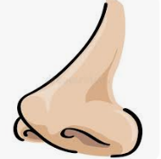
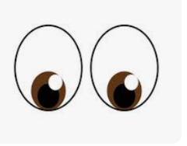
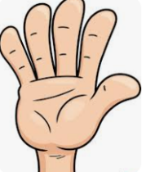
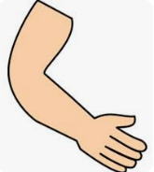

______________ _____________ __________________ _____________
B) Cümleleri okuyun ve resimlerin altına çocukların isimlerini yazın. (20p)
1) Mete likes playing instrument. His favourite school club is music club.
2) Eda likes drawing pictures. Her favourite school club is art club.
3) Mert likes reading. He is in the book club.
4) Asya likes playing volleyball. She is in the sports club.

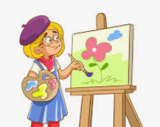
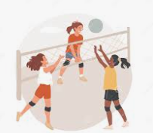
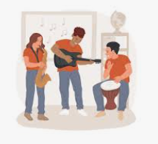

_______________ _______________ _______________ _________
C- Resimlerin altına uygun rutinleri yazınız. (30p)
-swimming - brush teeth - go to school - have a picnic - play football
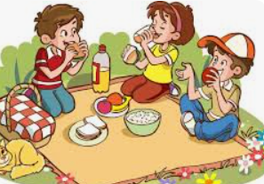 |  | 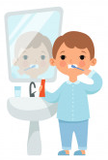 |  | 
______________ ______________ ____________ ___________ __________
D- Doğru seçeneği işaretleyiniz. (30p)

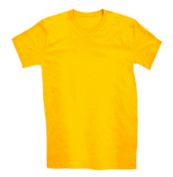
1-
What is this?
a) jeans
b) t-shirt

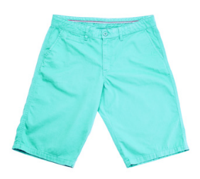
2-
What is this?
a) shorts
b) raincoat

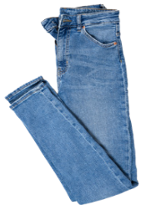
3-
What is this?
a) jeans
b) headscarf


4-
What is he doing?
a) He is having a picnic
b) He is fishing.

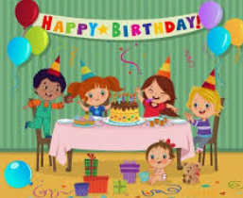
5- Where are they?
a) They are at an art museum.
b) They are at a birthday pary.

Not: Her soru 5 puandır.
https://www.ingilizceciyiz.com/

