2025-2026 EDUCATIONAL YEAR ……………………….. SECONDARY SCHOOL
5th GRADE 1st TERM 2N WRITTEN EXAM
NAME-SURNAME:…………………………………………………CLASS:…………………NUMBER:………………GRADE:………

- Look at the visuals and write down the places (5pts: 5X4=20 pts)

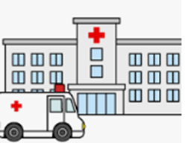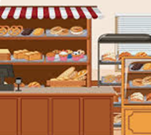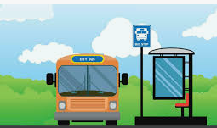
……………………………………. …………………………….. …………………………… ………………………………

- Read Jill’s stateents about his friends and answer the questions (4pts: 4x5=20 pts)
Hi. I’m Jill. I have two friends, Tom and Andy. Tom likes but he dislikes 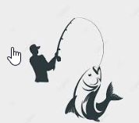

Andy can swim very well but he can’t play 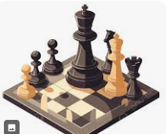. Tom is good at playing chess

- Who doesn’t like fishing ?
__________________________________________
- What can Andy do ?
_________________________________________
- What is Tom’s favourite activity ?
_________________________________________
- Can Andy play chess ?
_________________________________________
- Is Tom good at board games ?
_________________________________________
- Look at the table and complete the chart (4 pts: 4x5=20pts)

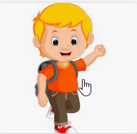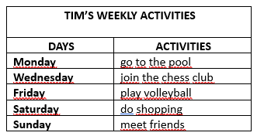

Tim swims on ------------------------------------------------. He ---------------------------------- on Wednesday.
He does sports on -----------------------------------. He ----------------------------------------and ----------------------------
at the weekends
- Look at the Martin’s daily routine and fill in the blanks (4pts:4X5=20 pts)
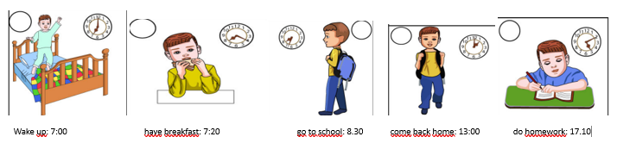
- At seven o’clock, Martin ----------------------------------------
- He has breakfast at -------------------------------------------
- He goes to school at -----------------------------------------
- At one o’clock, he --------------------------------------------
- He does homework at --------------------------------------

- Read the text and answer the questions (5pts: 5x4=20pts)

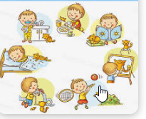

John always wakes up early on weekdays. He gets dressed and has breakfast with his parents at quarter past seven. Then, he brushes his teeth. He leaves home at half past seven. He gets back home at one o’clock and does his homework. In the evenings, he usually plays the guitar. He has a shower and goes to bed at quarter to nine.

a. Does John get up late on weekdays?
_____________________________________________
b. What does John do before he brushes his teeth?
______________________________________________
c.What does John do after he comes back home ?
______________________________________________
d. Does he play an instrument in the evenings ?
______________________________________________
e. What time does John sleep ?
_______________________________________________

Güncel Türkçe Matematik Fen Bilimleri Sosyal Bilgiler ve Din Kültürü Yazılıları İçin www.fenbilimleri.net’i Ziyaret Edebilirsiniz

