________________ ANATOLIAN HIGH SCHOOL
… EDUCATIONAL YEAR 1ST TERM 2ND INDIVIDUALIZED WRITTEN EXAM
FOR 10 GRADES.
NAME-SURNAME:
CLASS-NUMBER:

- Match the sentences with the pictures. ( cümleleri resimlerle eşleştir) 3x15= 45pts.
a b c
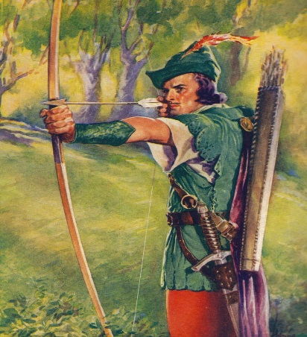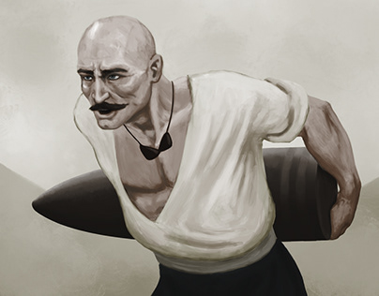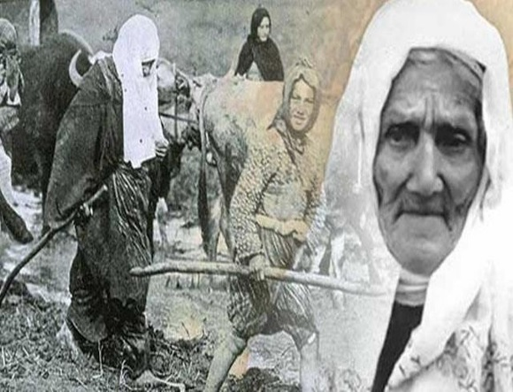
- Nene Hatun is the symbol of brave Turkish women in wars. ____
- Robin Hood fought against the Sheriff and won golden arrow. ____
- Seyit Ali carried cannonball weighing 215 kg. ____

- Answer the questions. Soruları cevaplayınız.
- Did she eat cheese ? 10pts
- Yes, your sister will take photo. b) No, his father doesn’t come. c) Yes, Zeynep ate.
- ‘’I wasn’t at home yesterday’’ cümlesinin Türkçe karşılığı nedir? 10pts
- Ben dün evde değildim. b) Ben dün evdeydim.

- Why was she crying ___________ you came in? Cümledeki boşluğa ‘’WHEN’’ yada ‘’WHILE’’ yazınız. 15pts

- Are they going to buy a new house next summer? 10 pts
- Yes I’m going to buy. b) No, They aren’t going to buy. c) No, we aren’t going to visit.

- ‘’A man of his word’’ deyiminin Türkçe karşılığı nedir? 10pts
- Sözünün adamı olmak. b) suçluyu yakalamak.

----------------------- --------------------- --------------------------- -------------------------
ELT ELT ELT Okul Müdürü

