MARK:
NAME/SURNAME:
CLASS:8/
NUMBER:
SÖNMEZ İMAM HATİP SECONDARY SCHOOL
2025-2026 ACADEMIC YEAR 1ST TERM 1ST ENGLISH EXAM FOR THE 8TH GRADES

E8.1.R2. Students will be able to understand short and simple invitation letters, cards and e-mails. (5*5=25 pts)

- Read the messages and write NAMES.
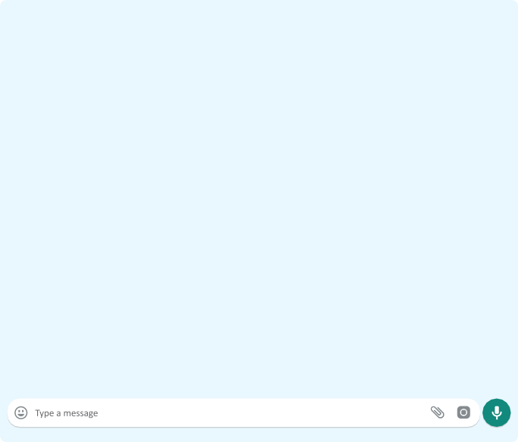

1.…………… refuses the invitation with an excuse.
2.……….…. accepts the invitation and asks for a detail.
3.……………… is having a pyjamas party tonight.
4……………..… loves parties.
5………………. invites her friends to an event.

Buddies Forever
Sally
Hey, buddies! We’re throwing a slumber party at my place tonight. Would you like to join us?
Elsa
Sounds great. I’m crazy about parties.
Emily
That would be great, but I have to help my mom.
Britney
I can’t refuse this invitation. What’s your address?

E8.1.W1. Students will be able to write a short and simple letter apologizing and giving reasons
for not attending a party in response to an invitation. (25 pts)

- Read the invitation card and write a short message to him/her apologizing and
making an excuse for not attending the party.


Dear Suzan,
I’m so excited to invite you to my birthday party!
Date: November 1
Time: 7 p.m.
Place: Glen Cafe
It will be a fun day with games, cake, and friends! I hope you can come!
Please let me know if you can make it.
Best,
Lucy


Dear ………………………………………………………………………………………………………………………………………………………………………………………………………………………………………………………………………………………………………………………………………………………………………………………………………………………………………………………………………………

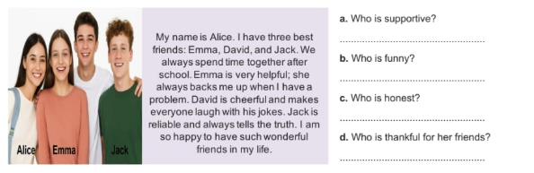
- Answer the following questions according to the text.
E8.1.R1. Students will be able to understand short and simple texts about friendship. (5*4=20 pts)

- Imagine that you received a letter from your penpal. Read the letter below and WRITE a similar one
telling ABOUT YOUR DAILY ROUTINES.(minimum 5 sentences)
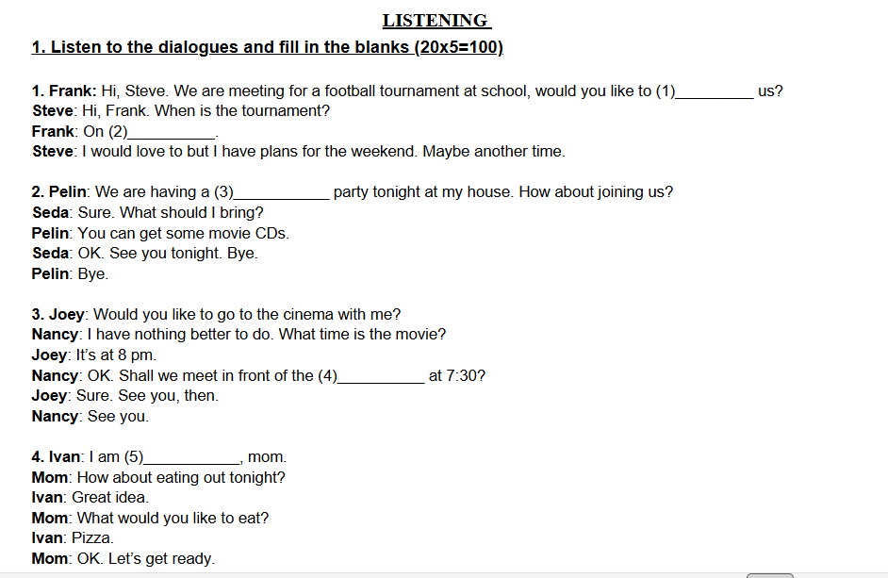

Hi, I’m Jason. I get up at 8 on weekdays. I always have a shower and get dressed before I have breakfast with my family. My school is close to school, so I walk to school. I’m at school from 9 am to 4 pm. After school, I usually practice tennis with my friends in our garden. Then, everybody goes home.
On schooldays, I watch TV only for half an hour, and then, I do my homework. My parents want me to play computer games only at weekends, so I play chess with my grandfather on weekdays. Write me back about your daily routines please.

