_____________________ VOCATIONAL AND TECHNICAL ANATOLIAN HIGH SCHOOL
2024-2025 EDUCATIONAL YEAR 2ND TERM 2ND INDIVIDUALIZED WRITTEN EXAM
FOR 9 GRADES.
NAME-SURNAME:
CLASS-NUMBER:

A- Circle the correct option. ( Doğru seçeneği daire içine alın) 4x5= 20pts
- There isn’t ANY / SOME water in the bottle.
- I bought A LOT OF / MUCH flowers to my mother for mother’s day.
- They WİLL VİSİT / VİSİTED museum tomorrow.
- It has got A / AN dark blue car.
B- Choose the turkish meanings of the sentences. ( Cümlelerin Türkçe anlamlarını seçiniz) 2x10= 20pts
- ‘’I haven’t find my key since yesterday.’’
- Dünden beri anahtarımı bulamadım b) Ben anahtarımı kaybetmem.

2. ‘’ We aren’t going to come to school next Monday. ’’
- Biz gelecek pazartesi okula gelmeyeceğiz. b) Biz gelecek pazartesi okula geleceğiz.

D- Match the sentences with pictures.(Cümleleri resimlerle eşleştiriniz) 6x10=60pts VOCABULARY 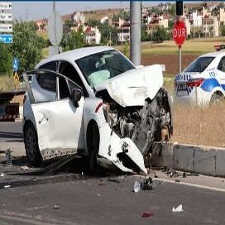  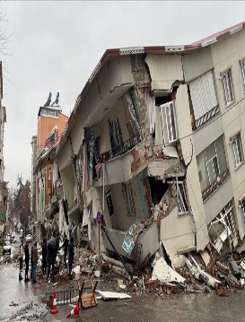  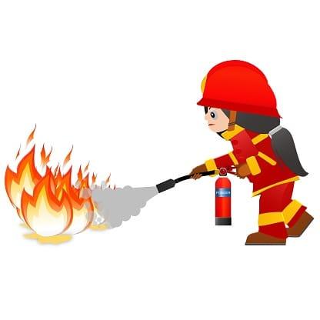
A B C D E F

- You have a headache, you should take painkiller. ______
- A big earthquake has happened in Kahramanmaraş, on 6th February 2023. ______
- She has a flue. I think, she should drink linden tea and keep warm. ______
- People must learn how to use a fire extinguisher. ______
- When the car accident happen, we should check ourselves for injuires and then call the police. ______
- Someone has hearth attack we should dial 112 or call the ambulance. ______

------------------ -------------------- --------------------- ------------------ --------------------
ELT ELT ELT ELT Okul Müdürü

