2024-2025 EDUCATIONAL YEAR … SECONDARY SCHOOL
2nd TERM 2nd INDIVIDUALIZED WRITTEN EXAM FOR 8th GRADE

NAME-SURNAME: CLASS-NUMBER: 8/

A) MATCH THE EXTREME SPORTS WITH PICTURES (20p)

- Motor racing 2. Paraglidin 3. İce climbing 4. Safari 5. skateboarding

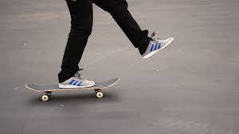

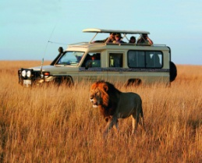
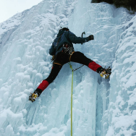

5 3 2 1 4
https://www.HangiSoru.com
B) MATCH THE CHORES WITH PICTURES (40p)

1. Take out the garbage 2. Set the table 3. Cook 4. Wash the dishes 5. Do the laundry
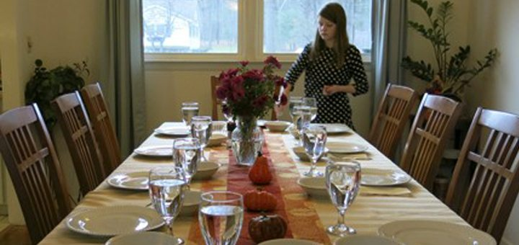
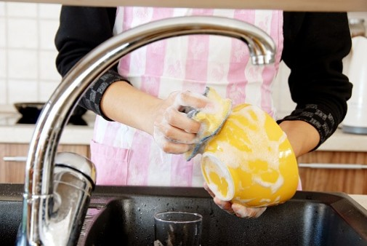
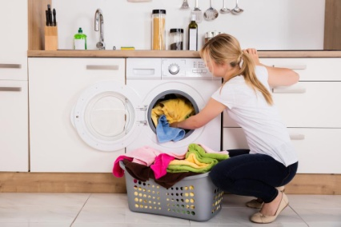

_______5________ ______4_________ ________2_______
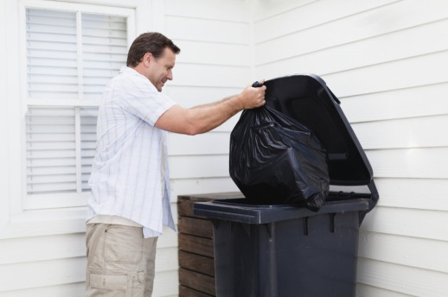


________1_______ _______3________

C) CHOOSE THE BEST OPTION (40p)
1- Büşra is in the kitchen. She is …………..
A) washing the car B) loading the dishwasher C) go shopping D) cleaning bedroom

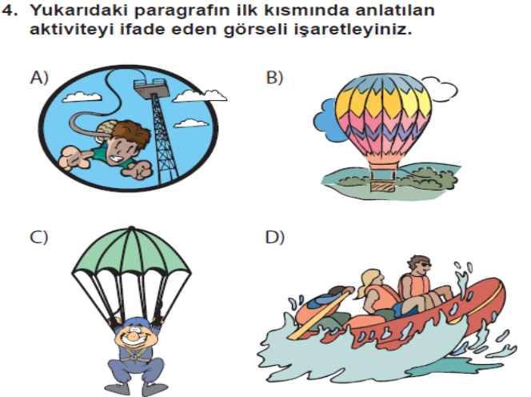
2-

Sally: Last summer I went to Nevşehir with my friend Kate. I tried a hot air balloon ride. It was wonderful.’

(C)

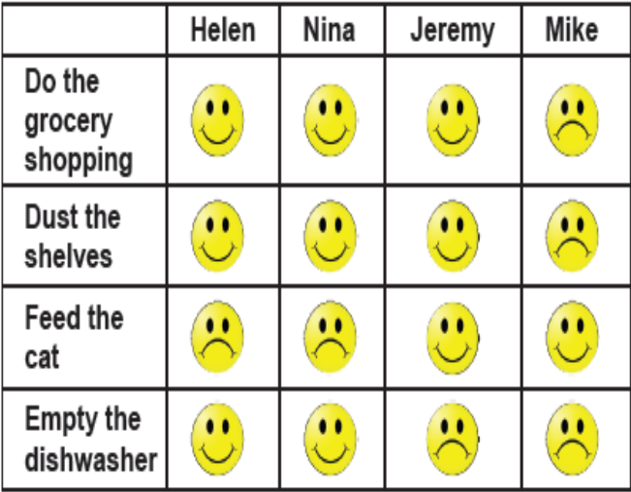
(3. ve 4. soruları tabloya göre cevaplayınız.)
3-Nina doesn’t like - - - - .

A) doing the grocery shopping
B) emptying the dishwasher
C) dusting the shelves
D) feeding the cat

4-Mike and Jeremy don’t like - - - - .

A) doing the grocery shopping
B) dusting the shelves
C) emptying the dishwasher
D) feeding the cat

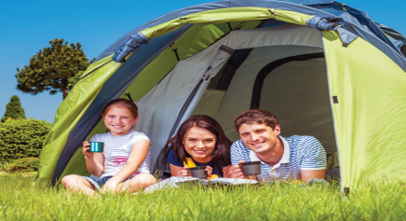
5- Ayşe: They prefer ___________.

a) beach vacation b) cruise vacation
c) camping vacation d) winter vacation

