Toplam Puan
..............

İNGİLİZCE 2. DÖNEM 2. YAZILI SINAVI

Adı: Soyadı: Sınıfı:

Soru
(10 Puan)
..................

Soru
(10 Puan)
..................

Soru
(10 Puan)
..................

Soru
(10 Puan)
..................

Soru
(10 Puan)
..................

Soru
(10 Puan)
..................

Soru
(10 Puan)
..................

Soru
(10 Puan)
..................

Soru
(10 Puan)
..................

Kazanım: E8.5.W1. Students will be able to write a basic paragraph to describe their internet habits.

- A computer science teacher is doing research about the Internet habits of teens.
Write a paragraph based on the answers to the following questions.
- How many hours do you spend online?
- How do you connect to the Internet?
- Do you follow the Internet safety rules?

Kazanım: E8.6.R1. Students will be able to understand short and simple texts to find the main points about adventures.

- Read the text below. Write down Charlie and his friends' names under their extreme sports preferences.
Charlie would rather go mountain climbing than go hang-gliding. He thinks it is more exciting. Kate hates swimming, but she loves skydiving. It is very entertaining for her.
Sharon can't scuba-diving, but she is good at motor racing. It is easy for her.

 | 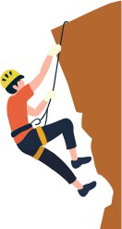 | 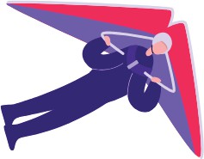 |  | 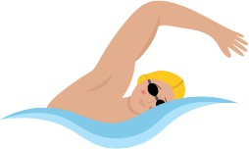 | 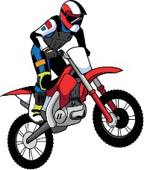

8. sınıf
2024-2025
2024 -2025

İNGİLİZCE
2. DÖNEM 2. YAZILI SINAVI Å

Kazanım:E8.7.R1. Students will be able to find specific information from various texts about tourism.

- Read the information about some of the famous landmarks of the world and answer the questions.
Famous Landmarks of the World |  | Description
Eiffel Tower, France | 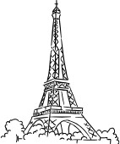 | A tall metal tower in Paris with great views.
Pyramids of Giza, Egypt | 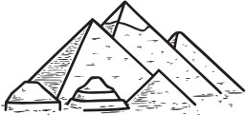 | Big stone structures in Egypt builts as tombs.
Sydney Opera House, Australia | 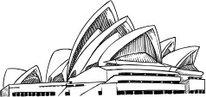 | A famous building in Sydney with a sail shape.
Statue of Liberty, USA |  | A big statue in New York that stands for freedom.
Machu Picchu, Peru | 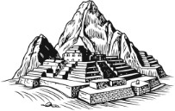 | An old city in Peru on a mountain with amazing views.

- In which city of France is the Eiffel Tower located?

- What does the Statue of Liberty stand for?

- Which of these famous landmarks is your favorite? Why?

2024-2025
8. sınıf

✓
2. DÖNEM 2. YAZILI SINAVI
İNGİLİZCE

Kazanım:E8.7.W1. Students will be able to design a brochure, advertisement or a postcard about their favorite tourist attraction(s).

- Choose your favorite tourist place and create a postcard.

Include:

  - A title

  - 3 reasons to visit

  - Accommodation options

  - Fun facts or interesting details




Kazanım: E8.8.R1. Students will be able to understand various short and simple texts about responsibilities.
- Read the text and answer the questions.
Burnham family does some household chores at home every week. The table below shows their responsibilities.

Responsibilities of Burnham Family

MON | TUE | WED | THU | FRI | SAT | SUN
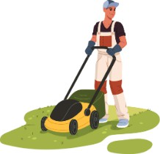 | 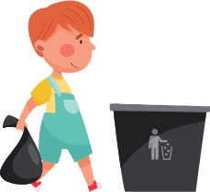 | 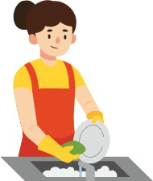 | 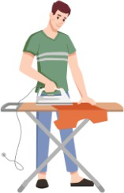 |  |  | 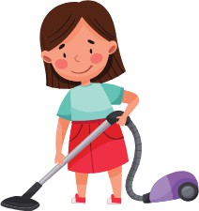

- How many days do they have indoor tasks?
- What do they do at the weekend?
- When do they mow the lawn?

sınıf
2024-2025

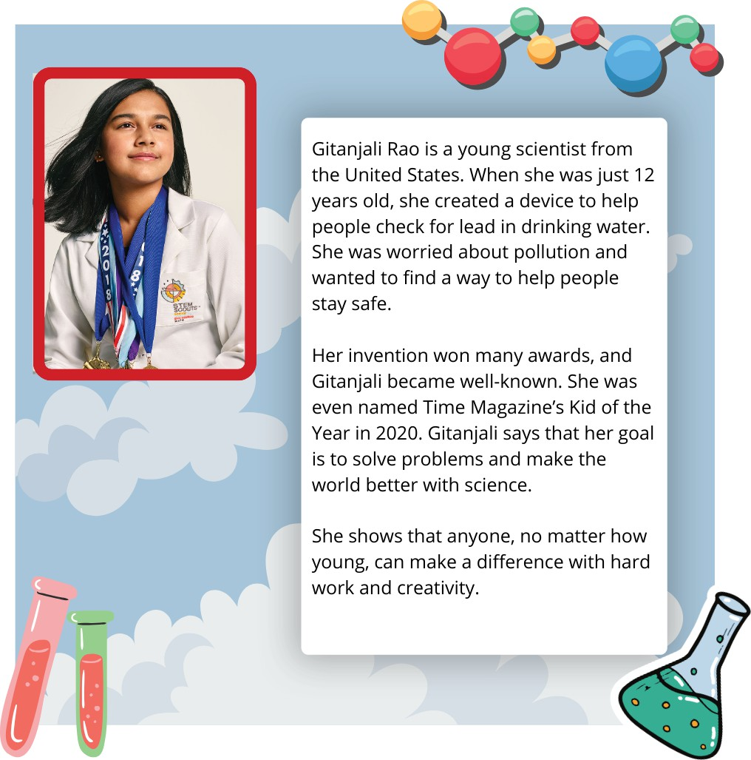
✓
2. DÖNEM 2. YAZILI SINAVI
İNGİLİZCE

Kazanım: E8.8.W1. Students will be able to write short and simple poems/stories about their feelings and responsibilities.

- Read the poem and complete the missing parts with suitable words.

Library Rules

In the library, so calm and fine,
-------------- your books on time.
Keep it ---------------, don't make a sound,
Let peaceful reading all around.

Don't --------------or drink, keep it clean,
The quietest place you've ever seen. Don't disturb, let others be,
In the library, respect is key!

Kazanım:E8.9.R1. Students will be able to understand short and simple texts about actions happening currently and in the past.

- Read the text below and answer the questions.

Gitanjali Rao is a young scientist from the United States. When she was just 12 years old, she created a device to help people check for lead in drinking water. She was worried about pollution and wanted to find a way to help people stay safe.
Her invention won many awards, and Gitanjali became well-known. She was even named Time Magazine's Kid of the Year in 2020. Gitanjali says that her goal is to solve problems and make the world better with science.
She shows that anyone, no matter how young, can make a difference with hard work and creativity.
- What device did Gitanjali Rao create when she was 12 years old?

- When was Gitanjali named Time Magazine's Kid of the Year?

- What is Gitanjali's goal in science?

2024-2025

sınıf

İNGİLİZCE 2. DÖNEM 2. YAZILI SINAVI

Kazanım:E8.9.R2. Students will be able to identify main ideas and supporting details in short texts about science.

- Read the table and answer the questions accordingly.

Electric Car | Bicycle | Telephone | Smartphone
Invertor: Elon Musk (Tesla) | Invertor: Karl von Drais | Invertor: Alexander Graham Bell | Invertor: Multiple invertors (Apple, Samsung, etc.)
Year: 2008 | Year: 1817 | Year: 1876 | Year: 2000s
Elon Musk developed electric cars that are better for the environment. They don't use gasoline and can be charged. | Karl von Drais created the first bicyle, a two-wheeled vehicle that allowed people to travel faster. | Alexander Graham Bell invented the telephone, which allowed people to talk to each other over long distances. | Smartphones are mobile phones with advanced features like internet access, touchscreens, and apps.

  - In which year was the electric car invented?
  - Who invented the telephone?
  - What is interesting about smartphones?

Kazanım:E8.9.W1. Students will be able to write simple descripitions of scientific achievements in a short paragraph.

- Pick one of the inventions below and write a short paragraph about why it's important, how we use it, and where we use it.


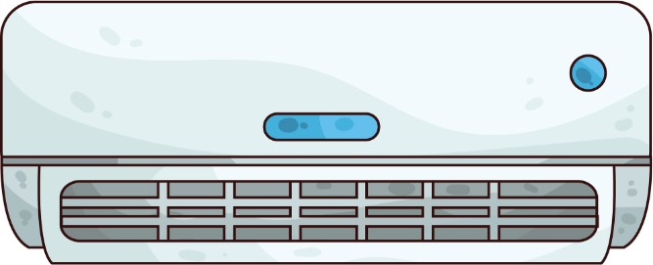

RADIO

Guglielmo Marconi
LIGHT BULB

Thomas Edison
AIR CONDITIONER

Willis Haviland Carrier

8. sınıf
2024-2025

