2024-2025 EDUCATIONAL YEAR … SECONDARY SCHOOL
2nd TERM 2nd INDIVIDUALIZED WRITTEN EXAM FOR 7th GRADE

NAME-SURNAME: CLASS-NUMBER: 7/

A) MATCH THE WORDS WITH PICTURES (30p)
PAPER GLASS RECYCLE

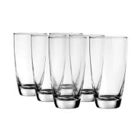



RECYCLE PAPER GLASS
B) WRITE SUITABLE PLACES NEXT TO THE PICTURES (35p)
- Green Grocer - Pharmacy - Boutique - Florist’s - Bakery

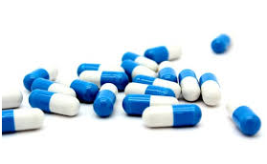 | Pharmacy
 | Florist’s
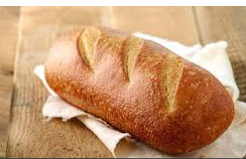 | Bakery
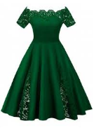 | Boutique
 | Green Grocer
CEVAPLAR SIRASIYLA: B A C C A
C) CHOOSE THE BEST OPTION (35p)
- If you have a health problem, you should go to a hospital.
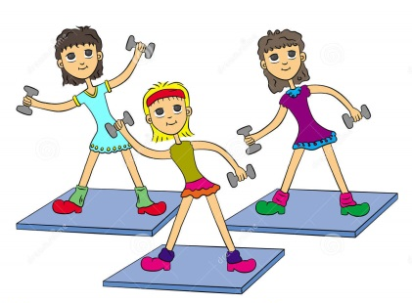
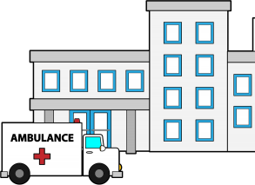
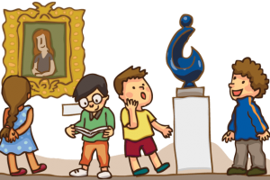
- b) c)

- We shouldn’t cut the trees.
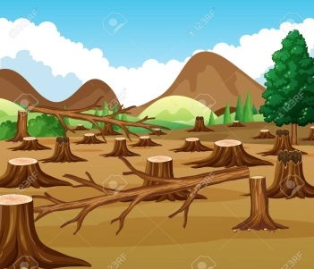
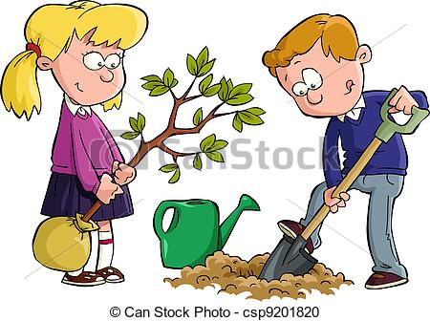
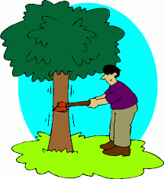
- b) c)

- We should use public transportation.
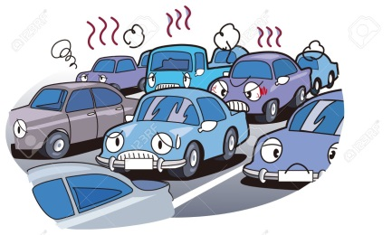
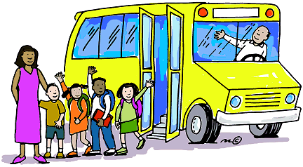

- b) c)

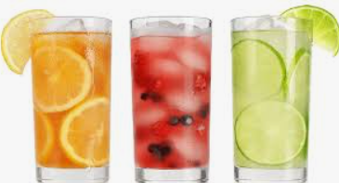
4. We need some …………… to drink. We don’t have enough.
A) fruit B) hats C) beverages D) food

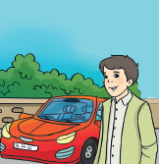
5.
a) He will buy a red car
b) he will have a good job
c) He will buy a house

