

Toplam Puan
..............

İNGİLİZCE 2. DÖNEM 2. YAZILI SINAVI

Adı: Soyadı: Sınıfı:

Soru
( Puan)
..................

Soru
( Puan)
..................

Soru
( Puan)
..................

Soru
( Puan)
..................

Soru
( Puan)
..................

Soru
( Puan)
..................

Soru
( Puan)
..................

Soru
( Puan)
..................

Kazanım: E7.5.R1. Students will be able to understand simple texts about daily routines and preferences.

- Read the speech bubbles and answer the questions.

I like learning the events in the world.
I prefer funny and enjoyable TV programs.
I don’t prefer real life programs.

Luna Mia Bella

  - Who doesn't like reality shows?
  - Who watches comedy movies?
  - Who watches the news?

Kazanım: E7.5.R2. Students will be able to understand simple texts about past events.

- Answer the questions according to the given blog.

Defne's Blog
I watched a soap opera last night. It was the last episode. Its name was Pembe Düşler. It was on the air for three years. It was about a big family. I think it was very exciting. My mother and I watched every episode of it.

Helpful: 256 Not helpful: 2
- What kind of a programme did Defne watch?

- What was the programme's name?

- What was the programme about?

- Do people think the blog is helpful?

7. sınıf
2024-2025
2024 -2025


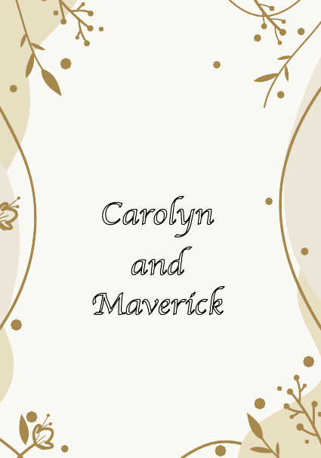
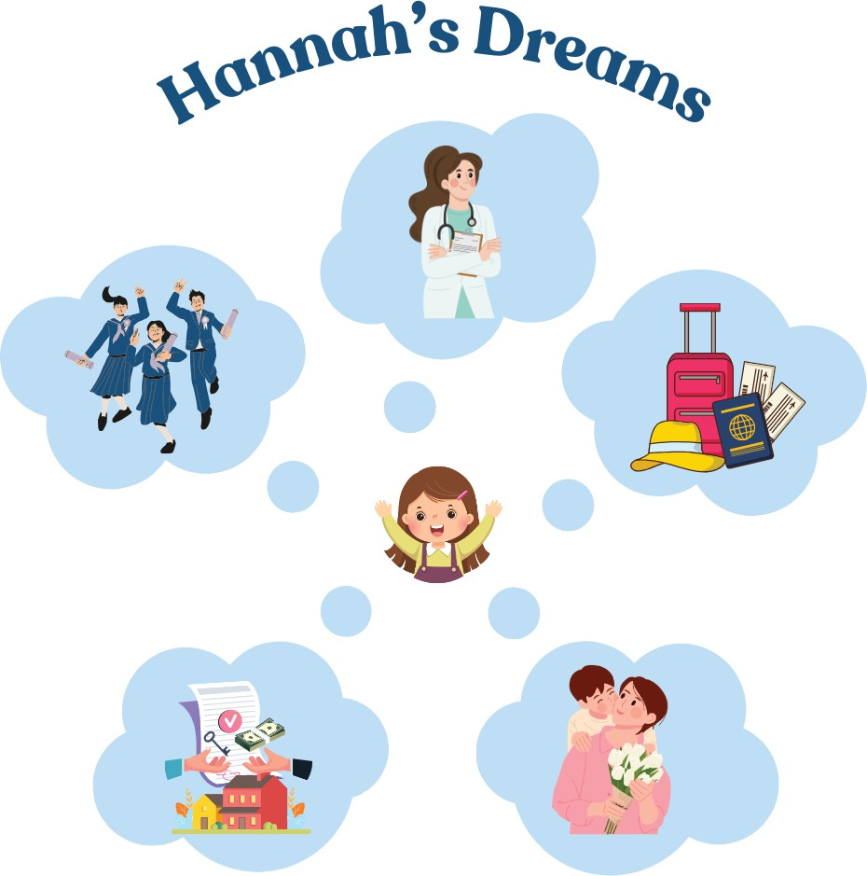
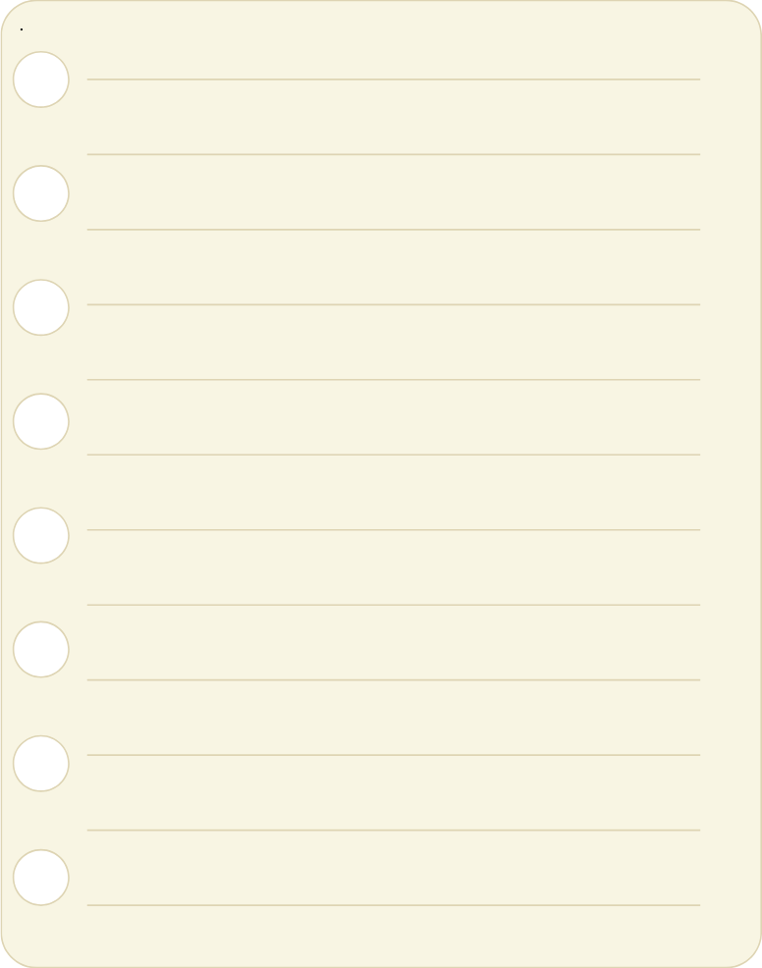
İNGİLİZCE
2. DÖNEM 2. YAZILI SINAVI Å

Kazanım: E7.6.R1. Students will be able to understand texts about celebrations.

- There are some mistakes in the sentences below.
Read the invitation card, correct the mistakes in the sentences, and rewrite them.

  - This invitation card is about a birthday party.

  - The event is on the 25th of November.

SAVE THE DATE
ANNOUNCING YHE MARRIAGE OF
Carolyn
and Maverick
FOURYH OF NOVEMBER, YWENYY YWENYY - FIVE

Brandon, Missouri

Kazanım: E7.7.W1. Students will be able to write pieces about predictions and future events.

- Look at the visual and write at least four sentences about Hannah's dreams.

2024-2025
7. sınıf

✓
2. DÖNEM 2. YAZILI SINAVI
İNGİLİZCE

Kazanım: E7.8.R1. Students will be able to understand simple expressions and recognize familiar words about explanations with reasons.

- Read what Melike and her family members did last weekend, and fill in the table with the correct names.
- Melike went to the bank to draw money.
- Selma went to the butcher to buy meat.
- Kıvanç went to the bakery to buy cake for Melike's birthday.
- Adem went to the chemist's to buy medicine.

What to do? | 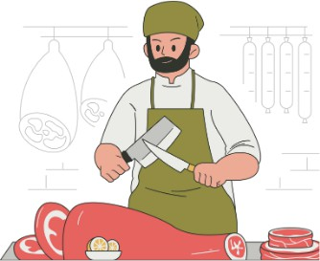 |  | 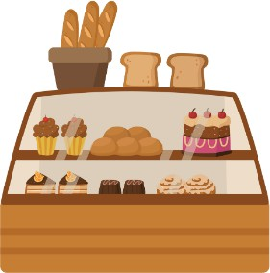 | 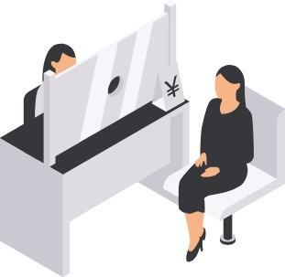
Who?

Kazanım: E7.8.W1. Students will be able to write pieces about explanations with reasons.

- Read the sentences below and complete them with suitable expressions.
  - Betül visited music store to

  - Kürşat called the fire station to

  - Ece went to the police station to

  - Tuna went to the beach to

7. sınıf
2024-2025

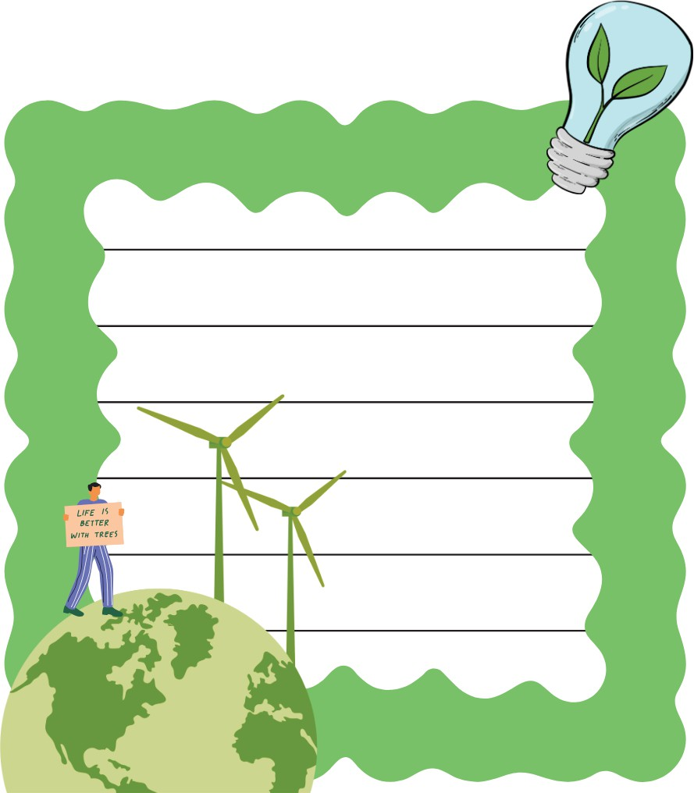
İNGİLİZCE
2. DÖNEM 2. YAZILI SINAVI Å

Kazanım: E7.9.R1. Students will be able to identify specific information in various texts about environment.

- Read the text and answer the questions.

The ozone layer ise very important for life on Earth. It protects us from the sun's harmful rays. When we release too much carbon dioxide into the air, it can hurt the ozone layer. Carbon dioxide comes from burning fuels like coal and gas. This makes the Earth hotter and causes climate change. It is important to reduce carbon dioxide to protect our planet.
  - What does the ozone layer protect us from?
.
  - Where does carbon dioxide come from?

  - Why is it important to reduce carbon dioxide?

Kazanım: E7.9.W2. Students will be able to write short description of a process.

- Imagine there is a competition at your school about saving water.
Look at the poster below and write a catchy slogan for it.

2024-2025 7. sınıf

