






Toplam Puan
..............

İNGİLİZCE 2. DÖNEM 2. YAZILI SINAVI

Adı: Soyadı: Sınıfı:

- Soru
( puan)
..................
- Soru
( puan)
..................
- Soru
( puan)
..................
- Soru
( puan)
..................
- Soru
( puan)
..................
- Soru
( puan)
..................
- Soru
( puan)
..................

Öğrenme Çıktısı: E5.6.R1. Students will be able to understand phrases and simple sentences on posters and advertisements about movies and movie characters.

- Look at the cinema ticket and complete the sentences.

SCREEN: 7 SEAT: E8
DATE: November 2
TIME: 20:30 PRICE: $15

flUtOta

----------------------------------- is a drama about a sad girl. It is playing at in the
evening at the cinema. The ticket is - - - - - - - - - - - - - - --.

Öğrenme Çıktısı: E5.7.R1. Students will be able to understand phrases and simple sentences on posters and advertisements about movies and movie characters.

- Read the text below and answer the questions.

  - What kind of party is Sue organising?

CARDflN PARTY
I am throwing a garden party at my new house. The party is on the fihh of April, Sunday.
It will start at 13:00. I hope you can come!
Sue

  - Where is the party?

  - When is the party?

5. sınıf
2023-2024
2024 -2025

✓
2. DÖNEM 2. YAZILI SINAVI
İNGİLİZCE

Öğrenme Çıktısı: E5.7.R1. Students will be able to understand short texts with visual aids, such as cartoons, posters and birthday cards.

- Read the conversation below and complete the note card. A: Let's throw a birthday party for Elif this weekend!
B: Sounds great! Where will it be?
A: At my house. Let's check what we need for the party.

We need

B: We need drinks, a big cake, balloons, and candles.
A: We don't need balloons ̶ I have plenty at home! Anything el- se?
B: We should get cookies and for decoration; colorful papers.
A: I'll bake the cookies myself, no need to buy them! What about a gift for Elif?
B: Yes, we can't forget the gift! Let's go shopping tomorrow.

Öğrenme Çıktısı: E5.8.R1. Students will be able to understand simple texts about sports activities.

- Read the text below and answer the questions.

Hello guys!
Let’s go hiking!
Why not?

Sounds good, but. I have other plans.

I’m sorry, but.
I must go home

Ethan Claire John Sayid

  - What is Ethan's suggestion?
  - Who wants to join the event?

  - How many people refuse Ethan's suggestion? Who are they?





2024-2025

sınıf


İNGİLİZCE 2. DÖNEM 2. YAZILI SINAVI

Öğrenme Çıktısı: E5.8.R1. Students will be able to understand simple texts about sports activities.

- Read the text below and answer the questions.

Mrs. Mosby asks her students to learn about their favorite activities. Here are their answers: Tommy loves doing fitness because he doesn't need any special equipment for it.
Maya loves playing table tennis, but she doesn't like playing tennis outdoors.
Ali doesn't prefer swimming in the sea during the summer, but he enjoys doing it indoors during winter. Lisa enjoys running in the park, and she always wears her favorite sneakers and running shorts.

of the students prefer indoor sports.
-----------------
> Maya's favorite activity is .
-----------------------------------
> Lisa always wears ------------------------------------- and -----------------------------------------, when she runs.

Öğrenme Çıktısı: E5.9.R1. Students will be able to understand short and simple texts about what people/animals are doing at the moment.

- Look at the picture and answer the questions.

  - What are the ducks doing?

  - What is the man doing?

  - What is the sheep doing?

5. sınıf
2024-2025

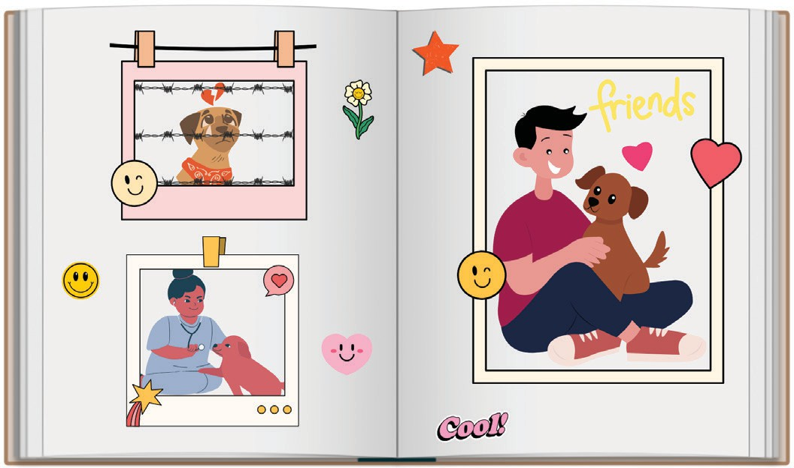
✓
2. DÖNEM 2. YAZILI SINAVI
İNGİLİZCE

Öğrenme Çıktısı: E5.9.R1. Students will be able to understand short and simple texts about what people/animals are doing at the moment.

- Look at the pictures of how the family adopted Buddy. Fill in the blanks using "Present Continuous Tense".

  - Buddy ----------------------------------for its
new owner. (wait)

  - The vet Buddy.
(examine)

  - The boy -------------------------------------------Buddy.
(hug)

