_________________ VOCATIONAL AND TECHNICAL ANATOLIAN HIGH SCHOOL
2024 – 2025 EDUCATIONAL YEAR 2ND TERM 2ND INDIVIDUALIZED WRITTEN EXAM
FOR 12 GRADES.

NAME-SURNAME:

CLASS-NUMBER:

- Read the text and reorder the events. 5x20= 100 pts


NEWS
Last night there was a burglary in our neighbourhood. Three men were seen breaking into a supermarket on our Street. There were seen by a lady who was walking her dog. She called the police arrived very quickly. When the men saw the police they escaped with a stolen car. But their car was stopped by another police patrol. The men were taken to police station and they were questioned separately. The three men were charged with burglary. At the same time, the supermarket owner was called and was invited to the police station. He came immediately and he was taken to his supermarket by the police. The supermarket owner told the police that some cash and cell phones were stolen from his market.

- Supermarket owner was invited to the police station. ____
- They were seen by a lady ____
- Three men broke into the supermarket last night ____
- They stole some cash and cell phones from the market ____
- They escaped when they saw the police ____
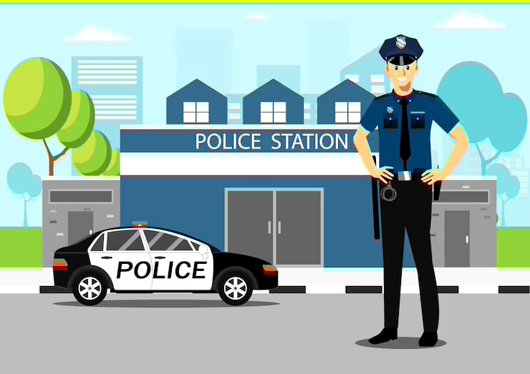

------------------- --------------------- ------------------ ------------------ -----------------
ELT ELT ELT ELT Okul Müdürü

