2024-2025 EDUCATIONAL YEAR … SECONDARY SCHOOL
2nd TERM 1st INDIVIDUALIZED WRITTEN EXAM FOR 8th GRADE

NAME-SURNAME:
CLASS-NUMBER: 8/
https://www.ingilizceciyiz.com/

A- VERİLEN SİMGELERİN ALTINA İNGİLİZCE ANLAMLARINI YAZINIZ (20p)
- DOWNLOAD - COMMENT - DELETE - INTERNET






______________ _________________ _________________ _______________

B- RESİMLERİN ALTINA İNGİLİZCE ANLAMLARINI YAZINIZ (40p)
- cycling - canoeing - hot air balloon - motor racing - rafting

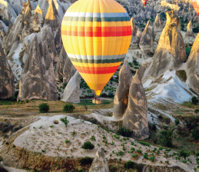 | 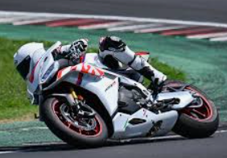 |  | 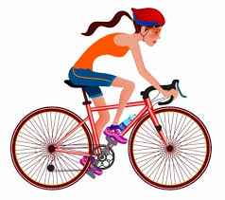 | 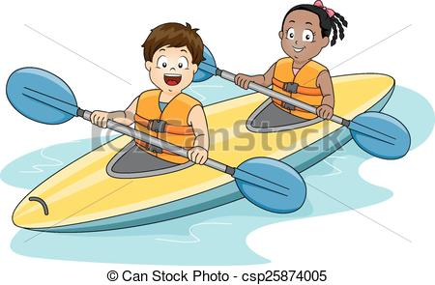

https://www.ingilizceciyiz.com/

C- DOĞRU SEÇENEĞİ İŞARETLEYİNİZ (40p) https://www.ingilizceciyiz.com/
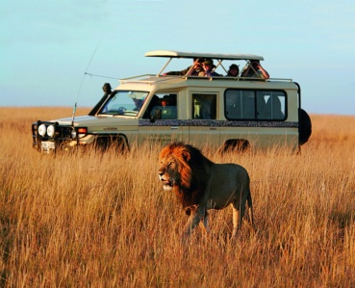
1- What extreme activity is it in the picture?

a) jeep safari b) hot air balloon

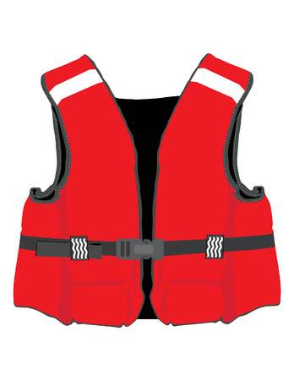
2- What is the name of the equipment in the picture?

a) life jacket b) helmet


3- What do they use the internet for?

a) doing shopping b) playing online games


4- _________________ is the most pupular search engine in the world.

a) yahoo b) Google

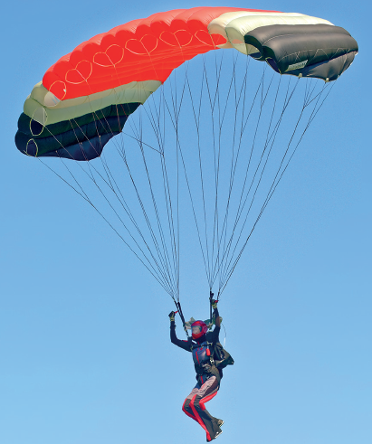
5. ____________________ is an air sport.

a) paragliding b) motor racing

https://www.ingilizceciyiz.com/

