2024-2025 EDUCATIONAL YEAR … SECONDARY SCHOOL
2nd TERM 1st INDIVIDUALIZED WRITTEN EXAM FOR 6th GRADE

NAME-SURNAME:
CLASS-NUMBER: 6/

A- RESİMLERİN ALTINA UYGUN HAVA DURUMLARINIZ YAZINIZ (20p)
sunny – snowy – windy – rainy

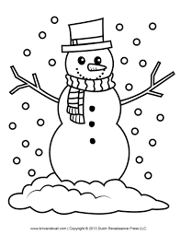
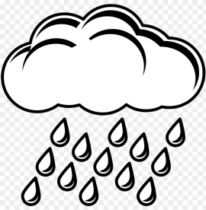



________________ ____________________ ____________________ ___________________

B- RESİMLERİN ALTINA UYGUN MESLEKLERİ YAZINIZ (30p)
cook – teacher – pilot – policeman - doctor

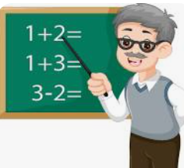


_________________ ____________________ __________________ ________________ ________________

C- LUNAPARKTAKİ OYUNCAKLARIN ADINI ALTLARINA YAZINIZ (30p)

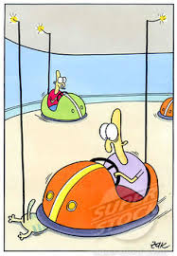
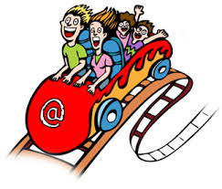
chairoplane - roller coaster - carousel - bumper cars - ferris wheel
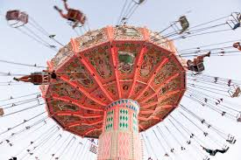
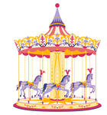
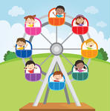
_________________ _________________ _________________ _________________ _________________

D - RESİMLERE BAKARAK DOĞRU SEÇENEĞİ İŞARETLEYİNİZ (20p)

1- He is ________________________.
a) reading book b) playing football


2- He is ________________________.
a) going to school b) playing basketball.


3- How does he feel?
a) He feels happy. b) He feels angry.

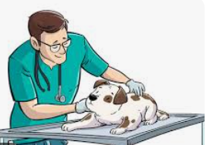
4- What is his job?
a) He is a vet. b) He is a doctor.

https://www.ingilizceciyiz.com/

