………………………...................ORTAOKULU
6.
SINIF
PUAN:
. … EĞİTİM ÖĞRETİM YILI Adı ………………………………………………
sb
İNGİLİZCE Soyadı …………………………………………
2. DÖNEM 1. YAZILI Sınıfı …………………. No …………………. ………………
1. Soru  (10 Puan) | 2. Soru  (15 Puan) | 3. Soru  (15 Puan) | 4. Soru  (15Puan) | 5. Soru  (15 Puan) | 6. Soru  (15 Puan) | 7. Soru  (15 Puan) | Aldığı  Puan
………… | ………… | ………… | ………… | ………… | ........... | ......... | …….
Aşağıda verilen açık uçlu soruları cevaplayınız.

S1
Complete the sentences according to the given text.
Emma enjoys visiting art galleries. She finds them inspiring and peaceful. Liam disagrees with Emma. He prefers amusement parks because they are full of fun and adventure. Olivia thinks zoos are fantastic places! She loves watching different animals and learning about them. Noah enjoys going to bookshops because he likes discovering new books and reading in a quiet place.
a. Emma loves going to ---------------------------------- because she finds them inspiring and peaceful.
b. Liam’s favourite place is --------------------------------------------------------------.
c. Olivia likes zoos because --------------------------------------------------------------.

S2
Answer the questions according to the poster given.
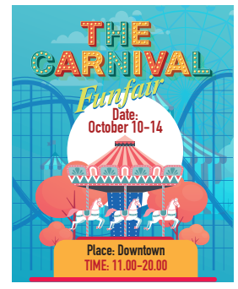
A) Where is the carnival?

B) What time does the carnival start?

C) When does the carnival finish?

S3
Read the text below, correct the mistakes and rewrite the sentences.
This is Tom. He was born in London on April 8, 1980. He used to be a doctor in a large hospital, but now he is retired. Now he just helps his neighbours.
a. Tom was born on April 8, 1990. → .......................................................

b. Tom is now a doctor in a hospital. → ......................................................

c. Tom is now a teacher. → ......................................................

S4
I'm Bob. I'm a doctor at the City Hospital. I became a doctor in 2012. I'm happy to be a doctor because I can
examine and help people when they are ill. I work from 8 a.m. to 5 p.m. on Monday and Tuesday. I work at night on Wednesday, Thursday, and Friday. I sometimes work at the weekend. It is a tiring job but it's my dream job.

a) When did he become a doctor?

b) He likes his job because - - - - .

c) According to the text, he - - - -

S5
I. I am a computer programmer.
II. Last year.
III. What do you do?
IV. When did you start working here?
Put the sentences above in the CORRECT order.

S6
I work at cafés and restaurants. I can serve food and drinks. I can also show you the empty tables. What is my job?

S7
Answer each question about yourself in one full sentence.

a. When were you born?

b. Where were you born?

c. What is your dream job? Why?

Not:Sınav süresi 40 dakikadır. …………………………….
Ders Öğretmeni

