………………………...................ORTAOKULU
6.
SINIF
PUAN:
. … EĞİTİM ÖĞRETİM YILI Adı ………………………………………………
sb
İNGİLİZCE Soyadı …………………………………………
2. DÖNEM 1. YAZILI Sınıfı …………………. No …………………. ………………
1. Soru  (10 Puan) | 2. Soru  (15 Puan) | 3. Soru  (15 Puan) | 4. Soru  (15Puan) | 5. Soru  (15 Puan) | 6. Soru  (15 Puan) | 7. Soru  (15 Puan) | Aldığı  Puan
………… | ………… | ………… | ………… | ………… | ........... | ......... | …….
Aşağıda verilen açık uçlu soruları cevaplayınız.

S1
Read the conversation below and answer the questions.
Mark: I love the Ferris wheel! Let’s go for a ride.
Sophie: I don’t think it’s a good idea. It is too high, and I am afraid of heights.
Daniel: I agree with Mark. It is really fun and relaxing.
Emma: It looks great, but I can’t ride the Ferris wheel. I am too small for it.

a. Who likes the Ferris wheel?

b. What does Sophie think about the Ferris wheel?

c. Can Emma ride the Ferris wheel?

S2
Complete the sentences according to the given poster
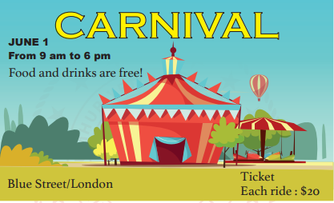
a. The date of the carnival is ---------------------------------------------------------------.

b. The carnival is open between ----------------------- and -----------------------------.

c. Each ride is-----------------------------------------------------------------------------------.

S3
Henry : Would you like to get on the roller coaster?
Sam : I want to get on it. It is exciting.
Mike : Thanks, but I think it is dangerous.
Lily : I don’t like it. It is boring.
George: I am not so sure about it.

A) Who accepts Henry’s offer?

B) Who refuses Henry’s offer?

C) What does Mike think about the roller coaster?

S4
Read the text below, correct the mistakes, and rewrite the sentences.
This is Emily. She was born on May 12, 1978, in Los Angeles. She was a teacher in the past, but now she is retired. She teaches her grandchildren at home now.

a. Emily was born on May 12, ..............

b. Emily ............. a teacher now.

c. Emily ..................... anyone now.

S5
Read the conversation below and complete the sentences with the jobs and dates as in Emma’s statement.
Could you tell us about yourself?
Emma: I am a doctor. I can help sick people. I was born on the tenth of April, 1980, in Paris.
Oliver: I am a/an -----------------------. I can teach students. I was born ------------------------------------------ (15.09.1992) in Berlin.
Sophia: I can fix pipes and taps. I am a/an ----------------. I was born ------------------------------------------- (2000) in Madrid.
Ethan: I am a/an ------------------------------. I can cook delicious meals in a restaurant. I was born ------------------------------------- (22.07.1975) in Rome.

S6
Answer each question about yourself in one full sentence.
a. When were you born?

b. Where were you born?

c. What is your dream job? Why?

S7
I’m Jennifer. I was born on August 16, 1984. I’m a nurse. I work at the city hospital. I help the doctors and patients. My work begins at 8:30 in the morning and finishes at 4 in the afternoon. I sometimes find my job hard, but I love it. It makes me feel good to help the patients.

A) How does she feel when she helps the patients?

B) What does she think about her job?

C) What time does her work start?

Not:Sınav süresi 40 dakikadır. …………………………….
Ders Öğretmeni

