2024-2025 EDUCATIONAL YEAR … SECONDARY SCHOOL
2nd TERM 1st INDIVIDUALIZED WRITTEN EXAM FOR 5th GRADE

NAME-SURNAME:
CLASS-NUMBER: 5/

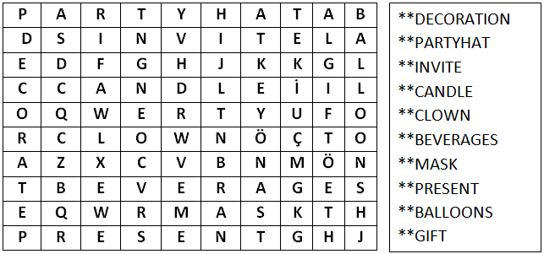
A- YAN TARAFTA VERİLEN KELİMELERİ AŞAĞIDAKİ BULMACADA BULUNUZ (30p)

B- RESİMLERİN ALTINA UYGUN KELİMELERİ YAZINIZ. (20p) https://www.ingilizceciyiz.com/
GIFT | BIRTHDAY CAKE | PYJAMAS | BALLOONS

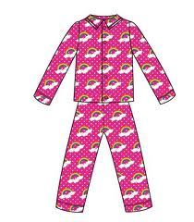



_____________ ___________ ___________ ______________

C - KELİMELERİ UYGUN PROGRAM İSİMLERİYLE EŞLEŞTİRİNİZ. (20p) https://www.ingilizceciyiz.com/
- cartoon ………….. a) Recep İvedik
- comedy film …………… b) Tom and Jerry
- documentary ………….. c)Animals World
- horror movie ………….. d) Deccal
D) AŞAĞIDAKİ ÇOCUĞUN VÜCUDUNUN BÖLÜMLERİNİ YAZINIZ. (15p)
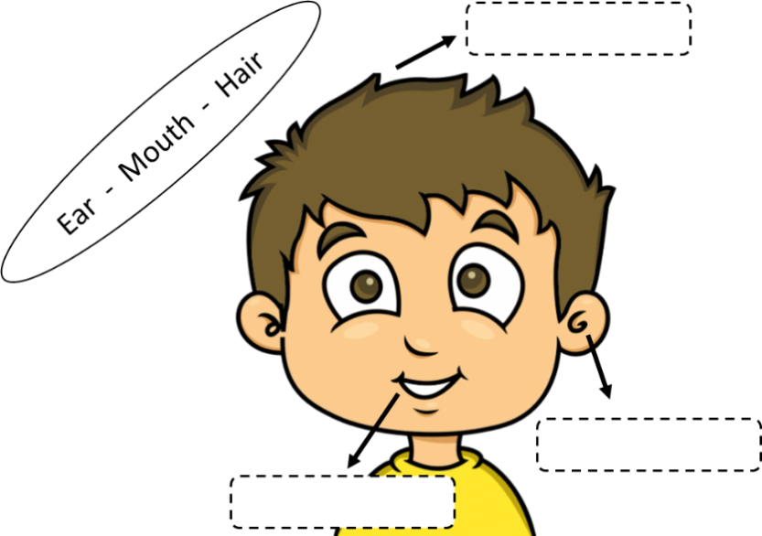

E- DOĞRU SEÇENEĞİ İŞARETLEYİNİZ (15p) https://www.ingilizceciyiz.com/

1- Jack has a stomachache. He shouldn’t ____________________ .

a) eat hamburger b) take medicine
2- Mary is ill. She should ____________________ .
a) go to school b) see a doctor


3- They are _________________________.
a) eyes b) ears
https://www.ingilizceciyiz.com/

