………………………...................ORTAOKULU
5.
SINIF
PUAN:
. … EĞİTİM ÖĞRETİM YILI Adı ………………………………………………
sb
İNGİLİZCE Soyadı …………………………………………
2. DÖNEM 1. YAZILI Sınıfı …………………. No …………………. ………………
1. Soru  (20 Puan) | 2. Soru  (15 Puan) | 3. Soru  (15 Puan) | 4. Soru  (20 Puan) | 5. Soru  (15 Puan) | 6. Soru  (15 Puan) | Aldığı  Puan
………… | ………… | ………… | ………… | ………… | ........... | …….
Aşağıda verilen açık uçlu soruları cevaplayınız.

S1
Emily is very tired today. She has a sore throat and a high fever.
She should drink plenty of water and get some sleep.

a. How does Emily feel?

b. What is wrong with Emily?

c. What should Emily do to feel better?

S2
Read the conversation below and fill in the form with the correct information.
Doctor: What is wrong with you?
Jake: I feel weak and have a fever.
Doctor: Do you have a sore throat?
Jake: Yes, doctor, and I have a headache.
Doctor: Hmm, I see. You have the flu.
Jake: Can I go to school today?
Doctor: I’m sorry, but you shouldn’t. You need to drink warm tea, take your medicine, and rest at home.
Jake: Thank you, doctor.
Doctor: You’re welcome. Get well soon.

Illnesses | Needs/Suggestions | Feelings

S3
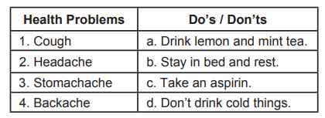
Match the letters and numbers given in the table below correctly.

S4
Brandon is currently in bed because he has a fever and is coughing a lot. He also feels tired. He doesn't want to go to the hospital because he is afraid of doctors. He doesn't take care of himself. He eats fast food and drinks soda a lot.
He hates vegetables. That's why he catches colds a lot.

A) What's wrong with Brandon?

B) Why does Brandon get sick so often?

C) Why doesn't Brandon want to go to the hospital?

S5
Betty : Science fiction movies are my favourite.
Robert : I love watching animations and horror movies.
Daisy : I don’t like action movies. I think they are boring.
Samuel : Watching comedy movies is exciting and great.
Who likes watching frightening movies?

S6
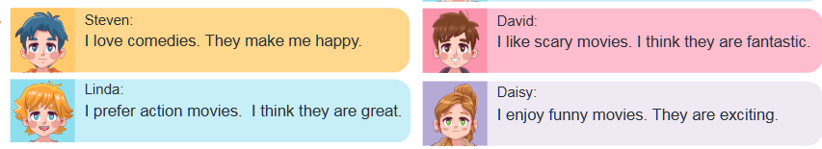
According to the table above, who likes the same kind of movies?

S7
Betty : Science fiction movies are my favourite.
Robert : I love watching animations and horror movies.
Daisy : I don’t like action movies. I think they are boring.
Samuel : Watching comedy movies is exciting and great.
Who likes watching frightening movies?

Not:Sınav süresi 40 dakikadır. …………………………….
Ders Öğretmeni
Cevap Anahtarı

