………………………...................ORTAOKULU
5.
SINIF
PUAN:
. … EĞİTİM ÖĞRETİM YILI Adı ………………………………………………
sb
İNGİLİZCE Soyadı …………………………………………
2. DÖNEM 1. YAZILI Sınıfı …………………. No …………………. ………………
1. Soru  (20 Puan) | 2. Soru  (15 Puan) | 3. Soru  (15 Puan) | 4. Soru  (20 Puan) | 5. Soru  (15 Puan) | 6. Soru  (15 Puan) | Aldığı  Puan
………… | ………… | ………… | ………… | ………… | ........... | …….
Aşağıda verilen açık uçlu soruları cevaplayınız.

S1
Read the conversation below and fill in the form with the correct information.
Doctor : What is wrong with you?
Molly : I feel very tired and bad.
Doctor : Do you have a runny nose?
Molly : Yes, madam, and I have a cough.
Doctor : Hmm, I see. You have a cold.
Molly : Can I go to work today?
Doctor : I am sorry, but you can’t. You should take these pills and have a rest at home for two days.
Molly : Thank you, Mrs. Writer.
Doctor : You’re welcome. Get well soon
Illnesses | Needs/Suggestions | Feelings

S2
Read the text below and answer the questions.
Thomas feels very ill today. He has a headache and runny nose. He needs to take his pills and have a rest.

a. How does Thomas feel?

b. What is wrong with Thomas?

c. What should Thomas do to feel better?

S3
Emma feels very tired today. She has a sore throat and a high fever. She needs to drink lots of water and get some rest.

a. How does Emma feel?

b. What is wrong with Emma?

c. What should Emma do to feel better?

S4
Mary and Jane are at their doctor's clinic today. The doctor fills in a form about them. Read the conversations and complete the form correctly. One picture is extra in each form!
Doctor : Hello, Mary. What’s wrong with you?  Mary : I don’t feel well today. I have a runny nose.  Doctor : Hmm, I see. Let me check! You have the flu.  Mary : Oh, can I go to school?  Doctor : No, you should take these pills and stay in the hospital tonight.  Mary : Thank you, Mrs. Bell. | Doctor : Good morning. How can I help you?  Jane : Hi, Mrs. Bell. I work long hours on the computer, and I have a terrible pain in my back.  Doctor : Hmm, you have a backache. You shouldn’t sit in a chair for two days.  Jane : OK, Mrs. Bell.  Doctor : Do these exercises at home regularly. They will help you feel better.  Jane : Thank you so much.
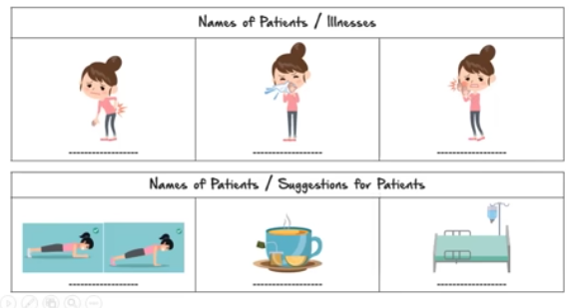

S5
Look at the cinema ticket and complete the sentences.

----------------------------------- is a drama about two besties. It is playing at --------------------------- in the evening
at the cinema. The ticket is ---------------------------.

S6
Look at the film poster below and answer the questions.
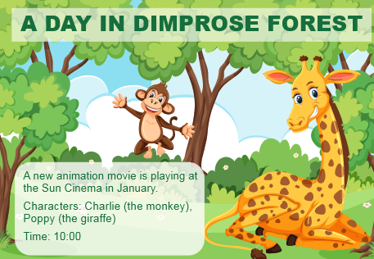
a. What is the name of the movie?

b. What kind of movie is it?

c. What time is the movie?

Not:Sınav süresi 40 dakikadır. …………………………….
Ders Öğretmeni

