_____________________ ANATOLIAN HIGH SCHOOL
2024 – 2025 EDUCATIONAL YEAR 2ND TERM 1ST INDIVIDUALIZED WRITTEN EXAM
FOR 9 GRADES.
NAME-SURNAME:
CLASS-NUMBER:

- Match the pictures with the sentences (Cümlelerle resimleri eşleştirin) 3x10= 30pts
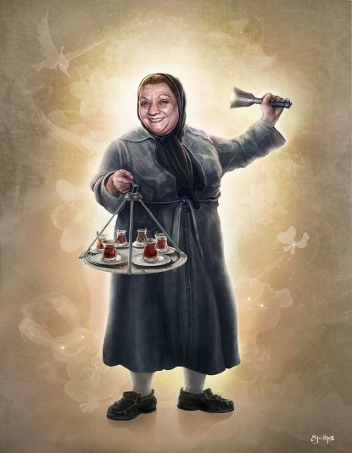
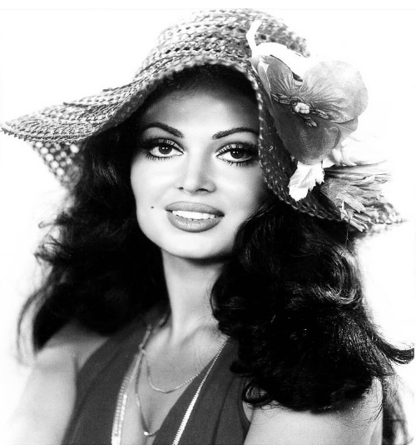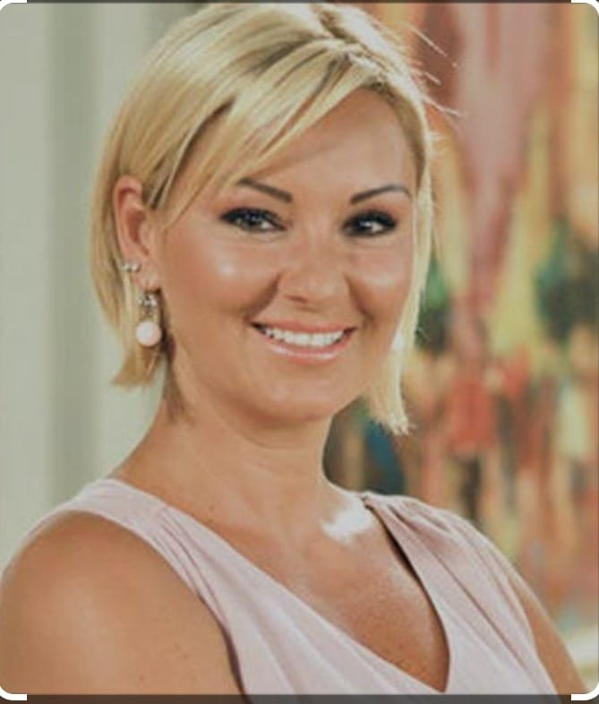
Adile NAŞİT Türkan ŞORAY Pınar Altuğ Atacan
Find Who they are with the given clues.
- She has got dark and wavy hair. She is good-looking, polite and so beautiful. She is called ‘’ queen’’ in Türkish cinemas. Who is she? _______________________________
- She is smiling, kind, cheerful, outgoing. She has got blond and short, straight hair.
Her famous series is ‘’çocuklar duymasın.’’ Did you watc it, didn’t you? Who is she? ________________
- She wasn’t tall. She was middle-weight and middle-aged in the picture. She was happy she loved children. She acted in hababam sınıfı. Her name was Hafize Ana in the film. Do you remember her? Who was she? __________________________________________

- Match the sentences meaningful. (Cümleleri anlamlı bir şekilde eşleştiriniz.) 5x10= 50pts
- I didn’t go to school yesterday. a- because she always wants to Eiffel Tower.
- The weather was sunny b- it is the most attractive places in Türkiye.
- My bestfriend, I study hard all the time c- so we went to Belgrad forest for having a picnic.
- Yelda is going to France this Sunday d- and we always pass all our exams.
- Cappadocia is in the world heritage list e- because I was ill.

- Circle the correct options. 5x4= 20pts
- Do they visit their grandparents every year, don’t / aren’t they?
- Let’s go to shopping mall, don’t / shall we?
- Call me after 20 minutes, will / did you?
- She didn’t tell any lie, did / is she?
- Were you in Germany in 2018, are / weren’t you?

