_________________ VOCATIONAL AND TECHNICAL ANATOLIAN HIGH SCHOOL
2024 – 2025 EDUCATIONAL YEAR 2ND TERM 1ST INDIVIDUALIZED WRITTEN EXAM
FOR 11 GRADES.
NAME-SURNAME: (SUNSHINE)
CLASS-NUMBER:

- Circle the correct option. (Doğru seçeneği daire içine alın) 2x4= 8pts
- There was COVID in 2020, nobody was outside because the government must / might have forbidden.
- Hagia Sophia was turned into mosque in 1975 / 2020

- Choose the turkish meanings of the idioms. 2x10= 20 pts
- ‘’give someone credit for something’’ Türkçe karşılığı nedir.
- Birine banka kredisi vermek. b) Birine hakkını vermek

- ‘’ miss the boat ‘’ Türkçe karşılığı nedir.
- Fırsatı kaçırmak b) Bot turunu özlemek

- Match the sentences with pictures. (Cümleleri resimlerle eşleştiriniz) 6x12= 72pts.

A B C D E F
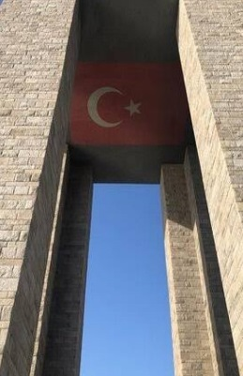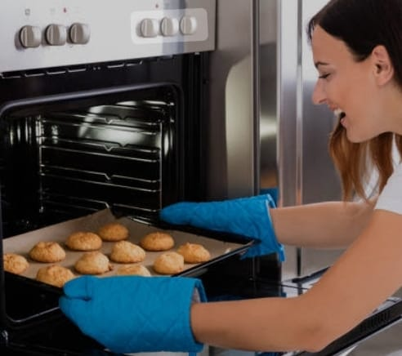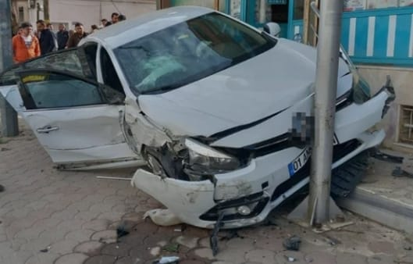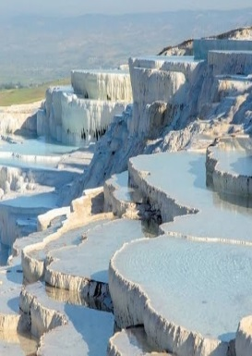

- Pamukkale hot springs and travertines are one of the most popular tourist destination in Türkiye. ____
- I have overcooked the cookies. I could have done better. ____
- We visited Çanakkale Martyrs Memorial two years ago. ____
- I wish I hadn’t had an accident. ____
- I could have studied more for the exam. ____
- I wish I had gone to the hospital early. ____

……………………. …………………….. ………………….. …………………… …………………….
ELT ELT ELT ELT Okul Müdürü

