_________________ VOCATIONAL AND TECHNICAL ANATOLIAN HIGH SCHOOL
2024 – 2025 EDUCATIONAL YEAR 2ND TERM 1ST INDIVIDUALIZED WRITTEN EXAM
FOR 11 GRADES.
NAME-SURNAME: (SPICE UP)
CLASS-NUMBER:

- Circle the correct option. (Doğru seçeneği daire içine alın) 2x10= 20pts
- There was COVID in 2020, nobody was outside because the government must / might have forbidden.
- Hagia Sophia was turned into mosque in 1975 / 2020.

- Choose the turkish meanings of the idioms. 2x10= 20 pts
- ‘’ open your heart ’’ Türkçe karşılığı nedir.
- Evini açmak. b) Kalpten-içten olmak

- ‘’ come clean ‘’ Türkçe karşılığı nedir.
- Doğruyu söylemek b) Temizliğe gelmek

- Match the sentences with pictures. (Cümleleri resimlerle eşleştiriniz) 5x12= 60pts.

A B C D E
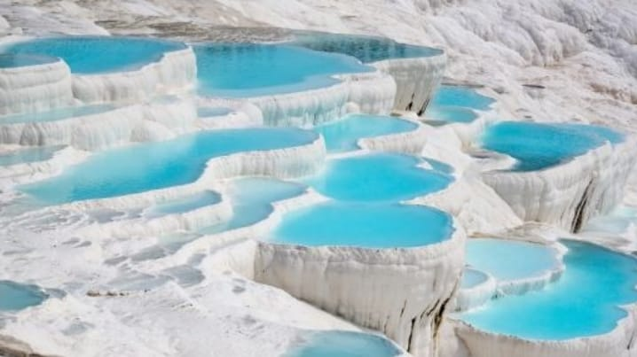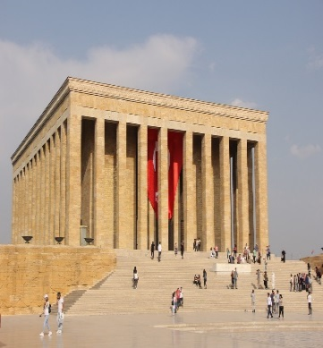

- Pamukkale is known for its white travertines terraces filled with warm mineral rich water. ____
- We visited Anıtkabir last 10th November. ____
- I wish the police had caught the thieves from their fingerprints. ____
- I could have studied more for the exam. ____
- I wish I had gone to the hospital early. ____

……………………. …………………….. ………………….. …………………… …………………….
ELT ELT ELT ELT Okul Müdürü

