15 TEMMUZ ANATOLIAN HIGH SCHOOL
9TH GRADERS 1ST TERM 2ND LISTENING EXAM
Name: Surname: Number: Class:
- Circle the correct options according to the listening track .
Jack invite Amy to …………… .
a) to his home b) to the cinema
Amy thinks watching a movie is …………. .
a) a terrible idea b) a good idea
Amy doesn’t like ………….. movies.
- Horror b) Comedy

Jack and Amy decided to watch a ………….. .
- Comedy b) Science fiction

- Listen to the recording and circle the correct options.

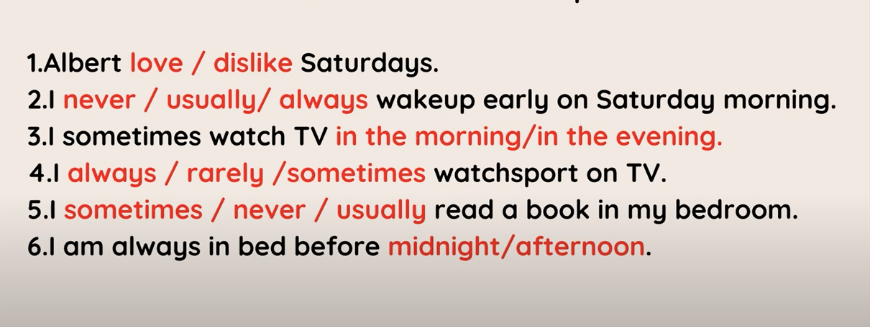
Yazılının ses dosyası: https://www.youtube.com/watch?v=HT-FaD3S1pk

