_______________________________ ANATOLIAN HIGH SCHOOL
2024-2025 EDUCATIONAL YEAR 1ST TERM 2ND INDIVIDUALIZED WRITTEN EXAM
FOR 9 GRADES.
NAME-SURNAME:
CLASS-NUMBER:

- Match the pictures with the sentences (Cümlelerle resimleri eşleştirin) 3x10= 30pts

( ) ( ) ( )
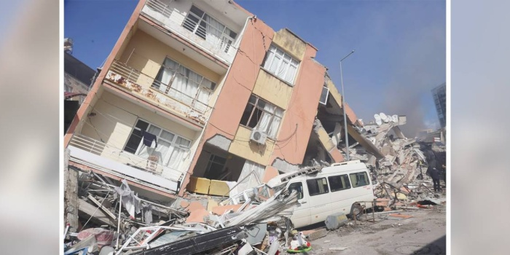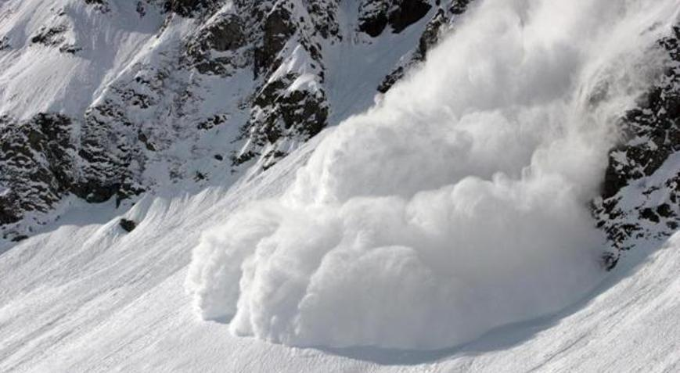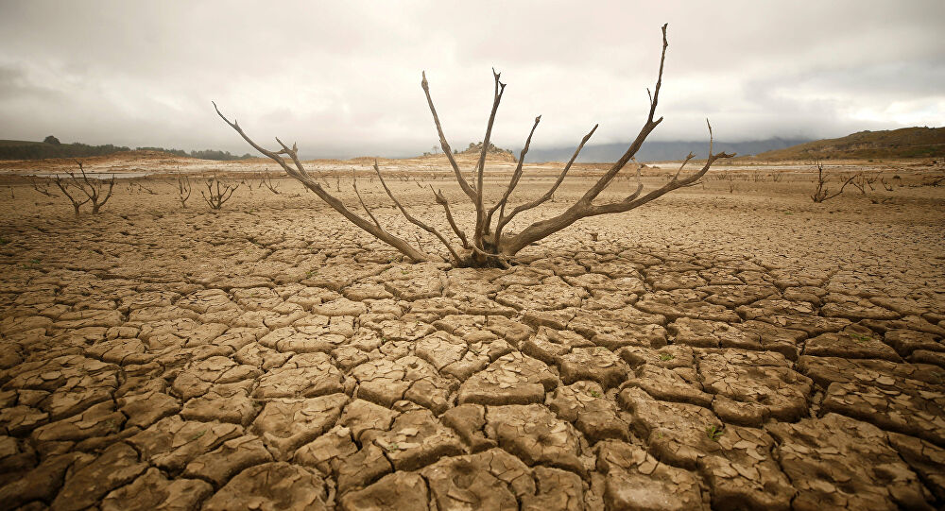

- Drought is a long period of time when there is no rain.
- Avalanche is a large amount of ice,snow falling quickly down the side of a mountain.
- A big earthquake has happened in Kahramanmaraş, on 6th February 2023.

- Underline the correct options. (Doğru seçeneklerin altını çiziniz) 5x10= 50pts
- My mother loves skiing so she can’t / can skii.
- A car can / can’t fly in the sky.
- I like / don’t like comedy movies because they are funny.
- A firefighter can / can’t save the people from fire.
- We always go / goes to picnic to Belgrad Forest every weekend.

- What time is it? Saat kaç? 4x5= 20pts


a b c d
- I always get up at quarter to seven. ____
- My first lesson starts at half past nine every day. ____
- My school bus usually comes at ten past eight. ____
- Our school sometimes finishes at four o’clock. ____

------------------ -------------------- --------------------- ------------------ --------------------
ELT ELT ELT ELT Okul Müdürü

