5
30 puan
ÖĞRENCİNİN
ADI: ................................................

SOYADI: .........................................

SINIFI: ............... NO: ...................

… EĞİTİM - ÖĞRETİM YILI
- SINIF İNGİLİZCE DERSİ
  - DÖNEM 2. YAZILI - 1 SINAV SORULARI
OKULUNUZUN ADI
.........................................................

.........................................................

.........................................................

Sınav süresi 40 dakikadır. Soruların Puan değerleri yanlarında yazmaktadır.

- Write the recipe of your favorite meal step by step. Talk about the process and ingredients.

Process

Ingredients
E8.3.W1. Students will be able to write a series of simple phrases and sentences by using linkers to describe a process.

- Read the recipe and answer the questions.
20 puan
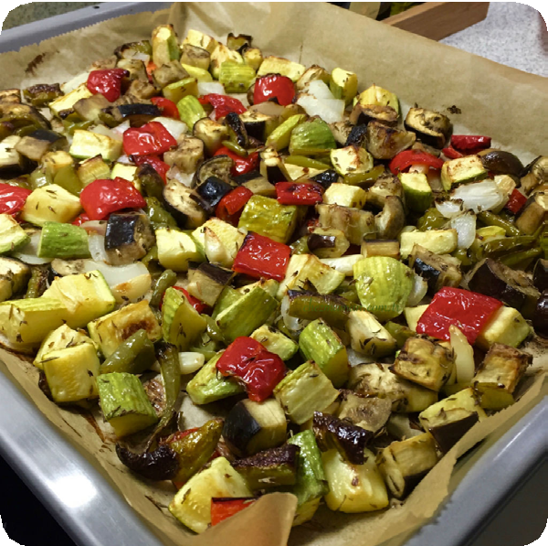

BAKED VEGETABLES
- Preheat the oven to 150 C degrees.
- Mix ½ cup of olive oil, 1 tablespoon of cummin, 1 teaspoon of black pepper, 1 cup of milk, and 1 tablespoon of salt in a bowl.
- Slice 4 potatoes and 2 carrots.
- Tie the potatoes with the mixture.
- Place the potatoes in a baking tray.
- Bake it for one hour.
Good Appetite!

1.
What kitchen tools do we need for the recipe?
.
2.
Which cooking method should we use?
.

3. What ingredients do we need?

4. How long should we bake it?

E8.3.R1. Students will be able to understand the overall meaning of short texts about a process.

8. Sınıf İngilizce Dersi 1. Dönem 2. Yazılı - 1

8. Sınıf İngilizce Dersi 1. Dönem 2. Yazılı - 1
- Read the dialogue and fill in the blanks.
20 puan
Martin : Hi! (1) ……………..….. Martin.
Gail : Hello! Gail speaking. Can I talk to Josh, please?
Martin :(2) ………………..…… minute. I’ll get him.
Gail : Okey. I’m waiting.

------------2 minutes later-----------------

Martin : I’m sorry, but Josh isn’t at home now. (3)……………………………………. ?
6
Gail : Sure. Can you tell him to call me back, please?
Martin : Sorry, it’s a bad line. (4) ……………………………………. ?
Gail : Can you tell him to call me back?
Martin : Of course. See you.
Gail : Good bye.

E8.4.W1. Students will be able to write short and simple conversations.

- What do you do when you are online? Talk about your internet activities
20 puan
...………………………………………………………………….…………………………….
………………………………………………………………………………………………….
………………………………………………………………………………………………….
E8.5.W1. Students will be able to write a basic paragraph to describe their internet habits.

- Read the text and cross the chart.
10 puan

We are a group of four friends. Each of us uses the Internet in our lives. We use it for different purposes.
Naomi usually browses articles. Julia enjoys using the Internet to watch videos and surfs on Instagram. Layton often watches foreign series to improve his French. I use the Internet to keep in touch with my friends. I use Messenger to communicate with them. Also, I follow a cooking course.
Kylie

 | Kylie | Naomi | Julia | Layton
read articles
learn a language
use social media
chat
follow courses

E8.5.R2. Students will be able to find specific information about the internet in various texts.

8. Sınıf İngilizce Dersi 1. Dönem 2. Yazılı - 1

