… EĞİTİM VE ÖĞRETİM YILI
SOMA YUNUS EMRE İMAM HATİP ORTAOKULU
8 - …… SINIFI İNGİLİZCE 1. DÖNEM 2. YAZILI
NAME: NUMBER: RESULT:
- Read the text and answer the questions below. ( Metni okuyun ve aşağıdaki soruları cevaplayın.)
(35 points)
Telephone is an important invention. People always want to keep in touch with each other. They used smoke signals, messenger birds and letters to connect with other people. After the invention of telephone, it provides people to connect with each other easily. Smart phones are the latest version of it. Everybody uses smart phones. We can use them easily in our pockets. But they may be harmful for our bodies. We can use the smart phones for internet banking and online shopping.
However, they may cause addiction. Also, they are very expensive.

- Do people like connecting with each other?
…………………………………………………………………………………………………………………….…………………
- What did people do to keep in touch with others in the past?
………………………………………………………………………………………………………………………………………….
- What happens after the invention of the telephone?
……………………………………………………………………………………………………………………………….............
- What are the pros of smart phones? (Write two of them. İkisini yaz.)
A ………………………………………………………………………
B……………………………………………………………………….
Fill in the blanks with the given words and phrases. One is extra. Verilen kelime ve ifadelerle
boşlukları doldurun. Biri fazla. (20 points)
“ tell him – speak to – take a memo – this is – leave a message - angry - available – calling –
hold on – sorry – his sister “
Jack : Hello, …………….. Jack ………………………. . May I Tom, please?
Mary : Hi, I am ………………………. . I’m ………………. but he isn’t at the moment.
Jack : Oh, OK. May I ?
Mary : …………………………. a minute, please. I’ll Yes, I’m listening to you.
Jack : Can you to call me back at 6 pm?
Mary : Of course, I can. See you. Bye. Jack : Thanks. Bye.

- Match the phrases and write five of them under the pictures. Kelimeleri eşleştirin(20 p) ve beşini doğru resimlerin altına yazın(10 p).
  - Crack ………………………… an apple
  - Sprinkle ……………………... some butter
  - Melt …………………………… some water
  - Whisk …………………………. the meatballs in a pan
  - Peel ……………………………… the eggs in a bowl
  - Pour ……………………………. two eggs
  - Boil ……………………………… some salt
  - Fry ……………………………… the cake
  - Chop …………………………… the mixture into a bowl
  - Slice ……………………………. the onions

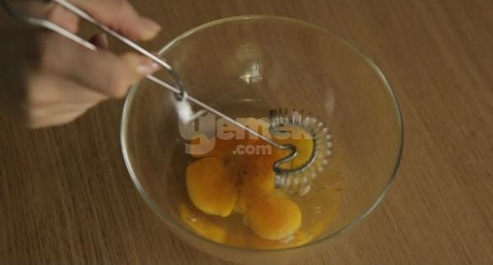
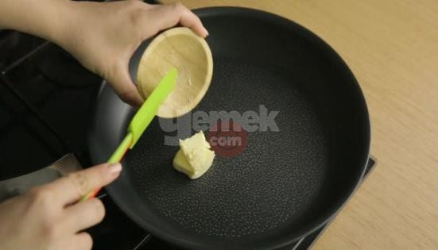

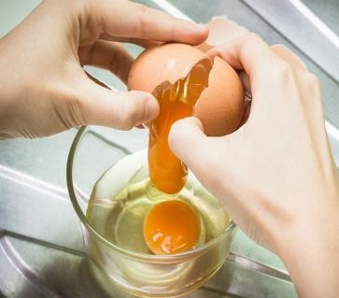

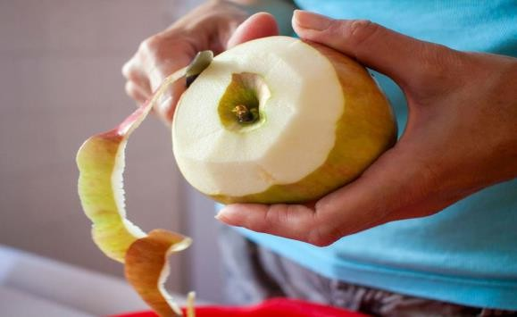

- Put the sequence words in the correct places. (Sıralama kelimeleriile boşlukları doldurun.)(15p) Adam usually gets up late on Sunday mornings. …………….., he washes his hands and face. ,
he helps his mother to make breakfast. ……………….breakfast, he tidies up his room , he
does his homework , he goes to cinema with his friends.
GOODLUCK!
Ali DURHAN Aysun ÇAMYARAN
İNGİLİZCE ÖĞRETMENİ İNGİLİZCE ÖĞRETMENİ

