2024-2025 EDUCATIONAL YEAR … SECONDARY SCHOOL
1ST TERM 2ND INDIVIDUALIZED WRITTEN EXAM FOR 6th GRADE

NAME-SURNAME:
CLASS-NUMBER: 6/

- HAVA KOŞULLARININ İNGİLİZCELERİNİ ALTLARINA YAZIN
sunny - cold - foggy - hot - snowy - cloudy -




………………… ……………... ………………….




…………………. ………………… ……………….

- RESİMLERİ VERİLEN DUYGULARI İNGİLİZCE KARŞILIKLARIYLA EŞLEŞTİRİNİZ.(10)

1. Energetic 2. Happy 3. Angry
4. Tired 5. Sleepy 6. Sad/Upset









- TABLOYA GÖRE CÜMLELERİN SONUNA DOĞRUYSA “TRUE” YANLIŞSA “FALSE” YAZIN (7P)
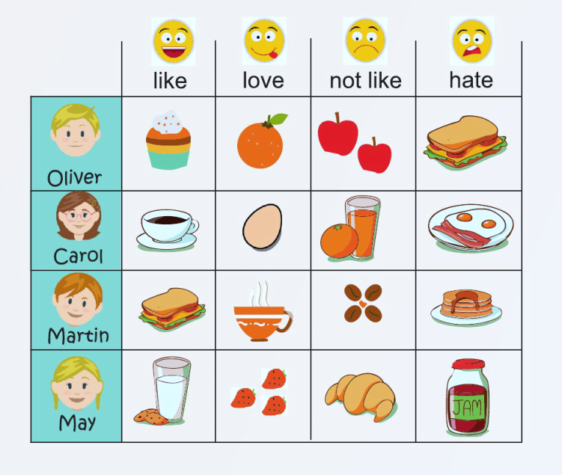

- Carol likes coffee. __________.
- May likes croissants. __________
- Martin hates pancakes. __________
- Oliver likes apple. __________.

D) DOĞRU SEÇENEĞİ İŞARETLEYİNİZ.
1-  What is she doing?

a) She is feding chicken. b) She is reading book.

2- 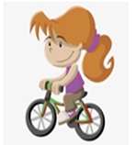 What is she doing?

a) She is driving a car. b) She is riding bicycle.

3- I like for breakfast.

a) muffin b) egg

4- What do they do everyday?

a) They play football. b) They do homework.

Not: Her soru 5 puandır. https://www.ingilizceciyiz.com/

