2024-2025 EDUCATIONAL YEAR … SECONDARY SCHOOL
1ST TERM 2ND INDIVIDUALIZED WRITTEN EXAM FOR 5th GRADE

NAME-SURNAME:
CLASS-NUMBER: 5/

A- Resimlerle aktiviteleri eşleştiriniz.

Camping Swimming Riding a bike Taking photos Playing football

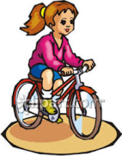





__________________ _____________ __________________ _____________ ____________
B)Boşlukları tabloya göre “can” ya da “can’t” ile doldurunuz.
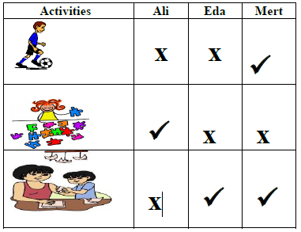
Örnek: Eda CAN do origami.
play soccer
1) Ali …………………………..... do origami.
2) Eda ………………………..…. play soccer.
do puzzle
3) Mert …………………….…….. do origami..
4) Eda and Mert ……………….………. do puzzles.
do origami
5) Ali and Eda…………………………….. play soccer.
C- Resimlerin altına uygun rutinleri yazınız.
-get dressed -brush teeth -go to school -get up -play soccer
 |  |  |  | 
D- Doğru seçeneği işaretleyiniz.
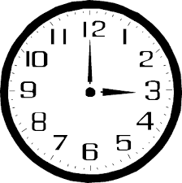
1- What time is it?
a) It ten o’clock.
b) It is five o’clock.

2- 4+3=? Yandaki işlemin sonucunu işaretleyiniz?
a) Seven
b) Six

3- What is your favourite game?
a) I like chess.
b) I don’t like reading book.

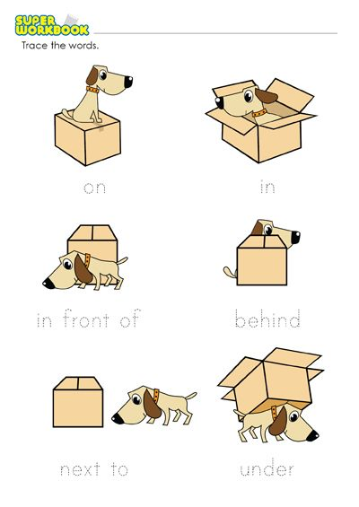
4- The dog is in the box.
a) b)



5- Jane likes but she dislikes

a) maths – music
b) science – turkish

Not: Her soru 5 puandır.
https://www.ingilizceciyiz.com/

