2024-2025 ACADEMIC YEAR … ANATOLIAN HIGH SCHOOL
FIRST TERM SECOND WRITTEN ENGLISH EXAM OF 12TH GRADES

NAME:

A)Read the sentences and fill in the blanks with the suitable form of the verbs” (50p)
1. They prefer ____________ (live) in a villa to ____________ (live) in a flat.
2. I would rather ____________ (stay) at home tonight than ____________ (go) out.
3. Hannah would rather ____________ (go) to Rome than Prague.
4. We prefer ____________ (listen) to classical music to ____________ (listen) to hip hop.
5. Ian prefers ____________ (work) in groups to ____________ (work) alone

B)Place the adjectives into the correct category (20p)

boring-funny-lazy-patient-generous-stubborn-kind-stingy-careless-cheerful

Positive adjectives Negative adjectives

C) Look at the Pictures and Make Sentences (30p)

1.    I like playing soccer but I don’t like taking photos
play soccer take photos

2.   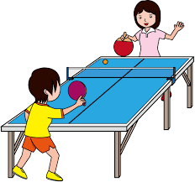 ………………….. but ………………
play blindman’s buff play table tennis

3.   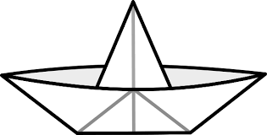 ……………………….but ……………………
Do puzzles do origami3

4.     …………………………….but ……………………
play game watch TV

