_________________ VOCATIONAL AND TECHNICAL ANATOLIAN HIGH SCHOOL
2024-2025 EDUCATIONAL YEAR 1ST TERM 2ND INDIVIDUALIZED WRITTEN EXAM
FOR 11 GRADES.
NAME-SURNAME:
CLASS-NUMBER:

- Read the text and wrrite ‘’TRUE’’ or ‘’FALSE’’. 7x10= 70pts.
(Metini okuyunuz ‘’DOĞRU’’ veya ‘’YANLIŞ’’ yazınız)
Aziz Sancar was born in Mardin on 8thSeptember,1946. After graduating from Istanbul University at the age of 24, returned to Mardin. He became a doctor. He won scholarship from TUBITAK to pursue further education in biochemistry at Johns Hopkins University.He couldn’t complete his PhD at Johns Hopkins University, but completed it University of Texas at Dallas. Then, Sancar worked as a lecturer at the University of North Carolina. Also, he has been a professor of biochemistry at the University of North Carolina.
His wife’s name is Gwen Boles Sancar. She is a professor at the same university. Mrs. And Mr. Sancar established Carolina Türk Evi for Turkish researchers. Aziz Sancar won Nobel Prize in 2015, he donated it to the mausoleum of Atatürk on 19 May 2016.

- Aziz Sancar was born on 19 May 1946. ____
- He completed his PhD University of Texas. ____
- Aziz Sancar won scholarship from TUBITAK at Istanbul University. ____
- He worked at University of North Carolina, as a lecturer. ____
- Mrs. Sancar has been a professor at Johns Hopkins University. ____
- He won Nobel Prize in 2016. ____
- He got married to Gwen. ____

- Match the words with the pictures.( Kelimeleri resimlerle eşleştiriniz) 4x5= 20pts

conquer / fleet / innovative / cannon

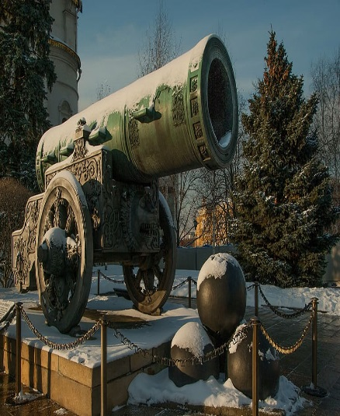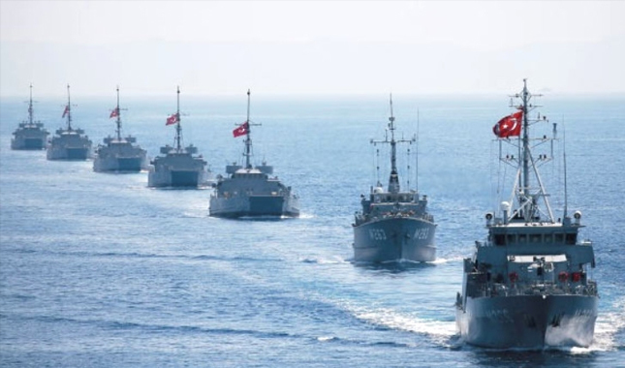

- Fill in the blanks with the ‘’WHEN’’ or ‘’WHILE’’. 5x2= 10pts
- ____________ I was dancing at the party, my friend took my photo.
- ____________ my father came in the kitchen, we were eating pizza.

……………………. …………………….. ………………….. …………………… …………………….
ELT ELT ELT ELT Okul Müdürü

