2024-2025 EDUCATIONAL YEAR … SECONDARY SCHOOL
1ST TERM 1ST INDIVIDUALIZED WRITTEN EXAM FOR 8th GRADE
https://www.ingilizceciyiz.com/
NAME-SURNAME:
CLASS-NUMBER: 8/

A- Aşağıdaki film türlerinden sevdiklerinize + , sevmediklerinize - koyun ve örnekteki gibi cümle yapın. (En az iki cümle yapınız) (20p)
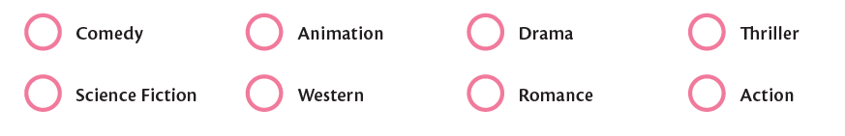

Örnek cümle: I like animation movies. I don’t like action movies.

1-
2-

B- Gençlerin yaptıkları aktivitelerin altına İngilizceleriniz yazınız. (30p)
- PLAY GUITAR - DRAW PICTURES - GO TO CINEMA
- PLAY VOLLEYBALL - RIDE BICYCLE - EAT SOMETHING AT A CAFE
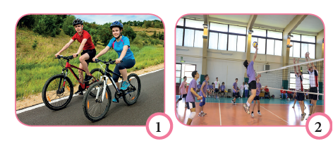
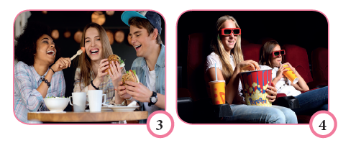

______________ ________________ ___________________ __________
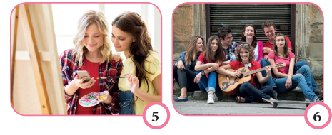

________________ ___________________
C- Cümleleri okuyun ve resimlerin altına uygun isimleri yazın. (20p)
AYŞE: “We have pyjamas parties with the girls.”
ASYA: “I love going to the theater with my friends.”
METE: “I like going to birthday parties.”
TUĞRA: “I like having a picnic with my family.”
GÖKTUĞ: “Amusement parks! I like spending time at the park.”
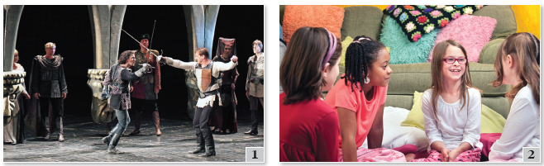
GÖKTÜRK: “We have great fun at the concerts. We listen to live music there.”


______________ _____________________ __________________ ________
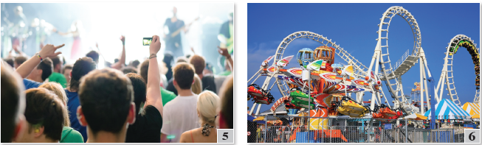

________________________ ________________________
https://www.ingilizceciyiz.com/
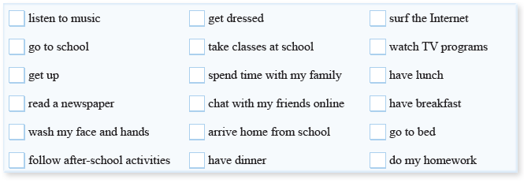
D- Metni okuyun ve Jack’in yaptığı aktiviteleri işaretleyin (30p)
Hello I’m Jack. I have breakfast and go to school in the mornings. After school, I like listening to music and surfing the internet. In the evenings,I do my homework and have dinner with my family.

